# 

# ESEEDS: AN AUTOMATED AGRICULTURAL SEEDS VENDING MACHINE

A Research/Capstone Project Presented to the Faculty of College of Computer Studies

**MINDORO STATE UNIVERSITY**

Calapan City Campus,

Masipit, Calapan City, Oriental Mindoro

In Partial Fulfillment

of the Requirements for the Degree

# BACHELOR OF SCIENCE IN INFORMATION TECHNOLOGY

by

**CRISTAL JOY C. ALFEREZ**

**MARTIN LAWRENCE M. CARINGAL**

February 2022

# APPROVAL SHEET

This Research/ Capstone Project Study entitled **ESEEDS: AN AUTOMATED AGRICULTURAL SEEDS VENDING MACHINE** prepared and submitted by **CRISTAL JOY C. ALFEREZ** and **MARTIN LAWRENCE M. CARINGAL** has been successfully presented and recommended for approval by the Advisory Committee in partial fulfillment of the requirements for the degree, **BACHELOR OF SCIENCE IN INFORMATION TECHNOLOGY.**

# ADVISORY COMMITTEE

**EPIE F. CUSTODIO, *MIT*** Adviser

_____________

Date

**FRANKLIN G. LOPEZ, MBA, *MIS***

Chairperson

_____________

Date

**REGINE A. PONCE-MACHETE, *MIT***

Technical Critic _____________

Date

**CHRISTIAN I. CABRERA**

Major Critic

_____________

Date

**VAUNE NIKOLE S. REDUBLO, *MAEd***

English Critic

_____________

Date

**LEONEL C. MENDOZA**

Research & Development Coordinator

_____________

Date

ACCEPTED and APPROVED in partial fulfillment of the requirements for the degree, **BACHELOR OF SCIENCE IN INFORMATION TECHNOLOGY.**

# JOHN EDGAR S. ANTHONY, *MSIT*

Dean, College of Computer Studies

# Date

# ACKNOWLEDGEMENT

The researchers wish to express gratitude to those persons who in one way or another contributed to the accomplishment of this research particular thanks is given to the following:

To Mrs. Maria Angeles C. Casubuan, researcher’s client, the owner of La Luce Feeds Supply, for enabling the researchers to deploy a vending machine in their business and assisting with the study's project.

Mrs. Epie F. Custodio, research adviser/panelist for contributing her finest skills, knowledge, time, and effort to examine the machine's enhancement and documentation, which aided in the completion of this study. Since the beginning of this project,

Mrs. Regine P. Machete, BSIT Department Capstone Instructor/panelist, who has provided unwavering support and useful recommendations,

Mr. Christian I. Cabrera, who has an IT expert/panelist that contribute the necessarily improvement and recommendation of the project.

Mr. Franklin G. Lopez, chairperson/panelist who verdict and deliver his best abilities, expertise and effort to the study's completion by examining the machine's enhancement and documentation.

Mrs. Vaune Nikole S. Redublo, English critic, the one who checked the grammar and composition of the research documentation.

Mr. John Edgar S. Anthony, dean of the college of computer studies, for contributing his best skills, knowledge, time, and effort to examine the project documentation, which also served to remind the researchers of their responsibilities and aided in the completion of this study.

To their parents, for their support, either morally, financially and understanding to finish the study and to comply with all their requirements.

To the researchers Alma Mater, Mindoro State University, Calapan City Campus, that made them strong in keeping the gained knowledge in shape and competent to all struggles towards to their goals in life.

And above all, to the great almighty, the author, of knowledge and wisdom, for His countless love, begins and guidance that have been given to them.

# C.J.C.A

**M.L.M.C**

**EXECUTIVE SUMMARY**

This research paper developed an automated selling technology for various variety packs of east-west seeds products from within the store of La Luce Feeds Supply, with practical and useful features for the agricultural store, where it solves the problem of inconvenient direct interaction, where the store experiencing labor-intensive from many customers, managing sales and customer retention. The researchers used evolutionary prototyping model SDLC. System Development Life Cycle (SDLC) is a series of phases in the device developmental process.

Its objectives are as follows: Develop an automated selling pack for a variety of east-west seeds; Integrate SMS to notify the administrator of remaining items and total sales; Incorporate SMS to allow the administrator to monitor and manage prices; Evaluate the developed project performance using ISO 25010; and implement the developed system.

The device provides a proper feature of automated selling of variety pack of east-west seeds for the agricultural store, the device can generate text messages for timely notifications of remaining seeds of each container from the vending machine with the capacity load of 10 to 15 item each, at the same time it also sends text messages for the update

of sales or as transaction records to the admin. It can also be changing its price of each container by the administrator, by using text messages specifically in sending code designated to change the prices in case that the price of the seeds needs to be updated. Environmental risk ready which the transaction is uninterruptible when power outage occurs unexpectedly. It can change coins if the customer has a remaining credit that already been inserted.

The device's performance is assessed using ISO 25010, and data for the study is collected using a survey questionnaire. The device is user-friendly and exceedingly convenient as a result of the findings, needing little learning effort to operate. Customers, staff, the owner, IT experts, and others gave the overall performance a high evaluation (4.39 or "Effective") from a total of 50 respondents. The study satisfies the needs of the users, and all of the study's objectives were met.

|  |  |
| --- | --- |
| **TABLE OF CONTENTS** | |
| **TITLE** | **PAGE** |
| **TITLE PAGE** | i |
| **APPROVAL SHEET** | ii |
| **ACKNOWLEDGEMENT** | iii |
| **EXECUTIVE SUMMARY** | v |
| **TABLE OF CONTENTS** | vii |
| **LIST OF FIGURE** | x |
| **LIST OF TABLE** | xii |
| **LIST OF APPENDICES** | xiii |
| **CHAPTER** |  |
| **I. INTRODUCTION** |  |
| Project Context | 1 |
| Objectives of the Study | 5 |
| Scope and Limitation of the Study | 5 |
| Significance of the Study | 7 |
| Conceptual Framework | 8 |
| Definition of Terms | 9 |
| **II. REVIEW OF RELATED LITERATURE/SYSTEM** | |
| Related Literature/System | 10 |
| Synthesis | 34 |
| **III. METHODOLOGY** |  |
| Development Method | 36 |
| Gantt Chart | 40 |
| Requirements Specification | 41 |
| Functional Requirements | 41 |
| User Interface | 43 |
| Hardware Interface | 44 |
| Software Interface | 45 |
| Communication Interface | 46 |
| Security Requirements | 47 |
| Technical Background | 47 |
| Hardware Specifications | 48 |
| Software Specifications | 49 |
| System Analysis and Design | 50 |
| System Overview | 50 |
| System Architecture | 52 |
| Use Case Diagram | 53 |
| Activity Diagram | 54 |
| Data Flow Diagram (DFD) | 55 |
| Context Diagram | 56 |
| Diagram 0 | 57 |
| Database Schema | 58 |
| Testing and Evaluation | 58 |
| Implementation Plan | 63 |
| **IV. RESULTS AND DISCUSSION** |  |
| Presentation of Project Output | 65 |
| Evaluation of the Project | 71 |
| Implementation Results | 84 |
| **V. SUMMARY, CONCLUSION AND RECOMMENDATION** | |
| Summary | 86 |
| Conclusions | 88 |
| Recommendations | 86 |
| **BIBLIOGRAPHY** | 90 |
| **APPENDICES** | 95 |

|  |  |  |
| --- | --- | --- |
|  | **LIST OF FIGURE** |  |
| **Number** | **Title** | **Page** |
| 1 | Conceptual Framework | 8 |
| 2 | Evolutionary Prototyping Model | 37 |
| 3 | User Interface of the Project | 43 |
| 4 | Schematic Diagram | 44 |
| 5 | Mobile SMS | 46 |
| 6 | System Architecture | 52 |
| 7 | Use Case Diagram of the Project | 53 |
| 8 | Activity Diagram | 54 |
| 9 | Context Diagram | 56 |
| 10 | Diagram 0 | 57 |
| 12 | Databased Schema | 58 |
| 13 | Insertions of Coins | 65 |
| 14 | Button Selections | 66 |
| 15 | Dispensed Seed Pack | 66 |
| 16 | Coin Change | 67 |
| 17 | Red Light Indicator | 68 |
| 18 | LCD Standby Mode | 68 |
| 19 | Inserted Credit Display | 69 |
| 20 | Delivering and Remaining Credits Display | 69 |
| 21 | Requiring Amount | 69 |
| 22 | Mobile Communication Admin Interface | 70 |

|  |  |  |
| --- | --- | --- |
|  | **LIST OF TABLE** |  |
| **Number** | **Title** | **Page** |
| 1 | Gantt Chart | 40 |
| 2 | Functional Requirements of the Project | 41 |
| 3 | Hardware Specifications | 48 |
| 4 | Software Specifications | 49 |
| 5 | Survey Questionnaire | 59 |
| 6 | Likert Scale | 63 |
| 7 | Implementation Plan | 64 |
| 8 | Functional Suitability of the Project | 71 |
| 9 | Reliability of the Project | 72 |
| 10 | Performance Efficiency of the Project | 73 |
| 11 | Usability of the Project | 75 |
| 12 | Security of the Project | 77 |
| 13 | Compatibility of the Project | 78 |
| 14 | Maintainability of the Project | 80 |
| 15 | Portability of the Project | 81 |
| 16 | Summary Results of the Evaluation | 83 |
| 17 | Implementation Results | 85 |

|  |  |  |
| --- | --- | --- |
|  | **LIST OF APPENDICES** |  |
| **Appendix** | **Title** | **Page** |
| A | Project Team Assignment Form | 95 |
| B | Capstone Project Topic Proposal Form | 96 |
| C | Notice of Title Acceptance | 113 |
| D | Endorsement for Final Defense | 114 |
| E | Grammarian Certificate | 115 |
| F | Certificate of Originality | 116 |
| G | Program Listing | 117 |
| H | Data Elements/Dictionary | 133 |
| I | Capstone Evaluation Form | 134 |
| J | Picture During Development | 138 |
| K | Pictures During Final Defense | 144 |
| L | Research/Capstone Project Waiver | 145 |
| M | Certificate of Oral Research Presentation | 146 |
| N | ACM Format | 147 |
| O | Curriculum Vitae | 153 |

# Chapter I

# INTRODUCTION

**Project Context**

The advancement of technology has had a significant impact on society. Life was difficult before modern technology, and daily activities took up much too much of our time. In modern culture, technology has become a particularly essential source of knowledge, and it has also opened up a number of new avenues for doing so. Access to education, medicine, industry, transportation, businesses and other services has been made easier thanks to contemporary technology. Our lives have substantially improved as a result of the convenience and efficiency afforded by technology.

According to East-West Seed Company, in 1982, East-West Seed pioneered market-oriented plant breeding in Southeast Asia, with the goal of increasing smallholder farmers' income through high-quality vegetable seeds. Smallholder farmers were the primary customers at the time, and they remain so now.

East-West Seeds has different types of seeds packaged each, which are sold in agricultural stores where the sale is usually traditional way or personal selling. Sometimes man power capabilities are lacking and something is needed that will boost sales or have more cost-effectiveness of selling seeds. The researchers came up with the idea of ​​implementing technology to sell seeds to improve and ease the sale of seeds which is on what we called vending machines.

The vending industry is rapidly growing. Vending machines can now be seen in malls and parks across the country. This new method of selling is already a big part of everyone's lives. This is why so many people fantasize of having a vending machine and profiting from such a convenient business.

According to Solano, A., Duro, N., Dormido, R., & González, P. (2017), a vending machine is essentially a business that has been automated. Products are placed into a machine and are normally accessible for purchase 24 hours a day, seven days a week. Common types of vending machines are freshly sold or produced beverages, bottles; cans, snacks, and fresh food are frequent vending products. However, it appears like there is no limit to what can be sold nowadays. A vending machine's selection number or corresponding button corresponds to each item. Customers make their payment, choose the corresponding item number or button and then wait for their chosen product to be dispensed. Vending machines come in all shapes and sizes these days. Freshly brewed hot drinks, cold cans and nibbles, fresh filtered water, confectionery, fresh food, hot cuisine, and even non-edible objects are all examples. To entice customers, machines might mix eye-catching displays with exciting, new products, engaging films, and stereo sound. There are two types of vending machines: pay vend and free vend. Cashless payments are becoming increasingly prevalent in today's world. Customers can pay with a credit card, cash, or cell phone. Customers can choose the selection number or the relevant button after making payment and wait for their desired product to be dispensed.

La Luce Feeds Supply is an agricultural store located in Barcenaga, Naujan Nautical Hwy. It was established in 1996 where they sell different agricultural supplies ranging but not limited to fertilizers, chemicals, seeds, animal feeds, supplements, and medicine. The owner of the store is Mrs. Maria Angeles C. Casubuan, the researcher's client for the project implementation. The Staff is currently employing traditional personal selling for all of its transactions where there are some issues that need to be resolved.

According to La Luce Feeds supply store’s staff and the owner, reaching a limited number of customers, labor intensive, ineffective selling retention due to ranges or number of customers, unrestricted prices and fault distribution are some of the flaws that the store is experiencing right now.

These problems were caused mainly by the manual selling operation within the store. This reason and problems led to the development of the ESEEDS: An Automated Agricultural Seeds Vending Machine.

The project can help to maximize the store’s productivity, reduce delay and waiting time, cost- effectiveness, secure prices and its distribution to aid customers. Providing conveniences for agricultural customers and client’s agricultural store, with the help of technological implementation, which is the use of vending machine that allow customers to purchase the seeds they want to grow or plant, as well as features that allow customers to buy and pay without the need for assistance.

# Objectives of the Study

Generally, this study aimed to design and develop ESEEDS: An Automated Agricultural Seeds Vending Machine for La Luce Feeds Supply store.

Specifically, this study aimed to:

1. Develop an automated selling packs for the variety of east-west seeds;
2. Integrate SMS to notify the administrator for the remaining items and total sales;
3. Incorporate SMS that will allow administrator to monitor and manage prices;
4. Evaluate the developed project performance using ISO 25010; and
5. Implement the developed device to the respective client.

# Scope and Limitation of the Study

This study was primarily developed for an agricultural store that offers convenient seed selling services to its staff and consumers, such as an automated selling procedure and sales transaction data. The device covers the sale of a variety of seeds to agricultural customers while sending reports on the item's remaining stock and total sales transaction. The admin can restock seeds, update pricing, replenish coins in the coin hopper, reload GSM, and receive SMS notifications of the remaining items and total sales. Agricultural customers can choose and buy different types of seeds packs according to the seeds they want and also according to its price. Customers in the agricultural sector can simply get their change thanks to the project's coin changer and coin retriever, as well as an emergency power supply for the machine in the event of a power outage.

The device is limited only to cater agricultural sector in terms of seed sales and its variety. Other agricultural products will not be accepted for sale by the device. The device's item loading capacity is limited, ranging from 10 to 15 items per container. The device only accepts old and new peso coins in denominations of one, five, and ten pesos. The device will not dispense item until required credits are completely inserted. The pricing of the devices can only be specified between 1 and 255. The coin hopper reloading mechanisms can only be set in one peso currency. Only a special admin texting code can be configured for the device's pricing changing feature. The device emergency power supply can last only about one to five hours without charging.

# Significance of the Study

The researchers developed a vending machine which will benefit the following people in particular:

**Store Staff.** The study's results will assist the staff in improving manageability and productivity. This will reduce the labor intensive they are experiencing.

**Store Manager.** The management of agriculture store is a government agency which is responsible for the promotion of agricultural development by providing framework, public investments, and support services needed for domestic and export-oriented business enterprises, which the result of the study will contribute to the ever-growing agricultural development society. The findings of this research will assist management in improving the way they conduct business interaction.

**Consumers.** The study will help assist customers that allow them to purchase seeds without the need of personal assisting, resulting to a convenient transaction.

**Entrepreneurs/Technopreneurs.** The study's results contribute to the knowledge of entrepreneurial enthusiasts with the use of technology combined with business practitioners will possibly be enhanced as a result of this research.

**Future Researchers.** This hardware development research can be used as a guide and reference material in their developmental study. Business students will gain a competitive advantage, as well as a future reference that will motivate them to start their own company.

# Conceptual Framework

This section explains the overall concept of this study. Make the project possible by using input-process-output.

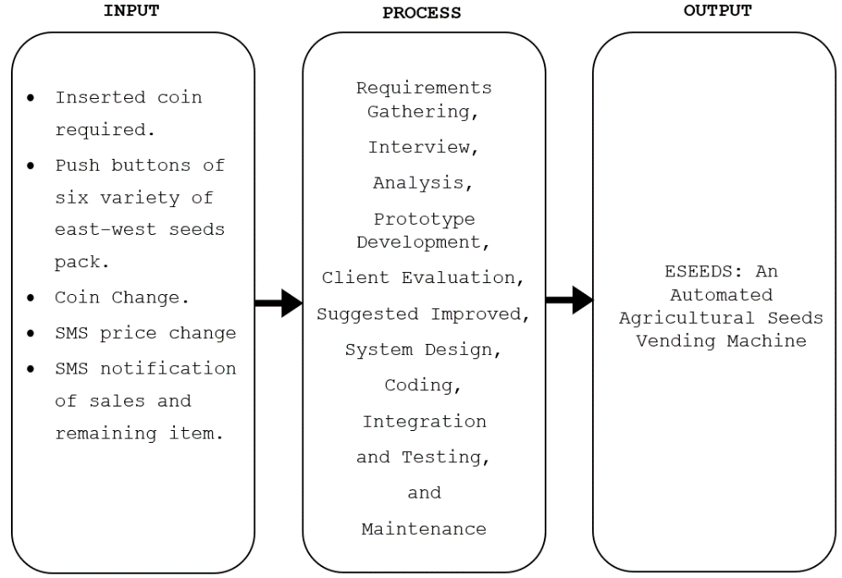

# Figure 1. Conceptual Framework of the Study

Figure 1 indicates the concept of the study. It illustrates the seed vending machine's input, process, and output. The input includes the machine or device's features, as well as processes including requirement gathering, interviewing, planning, analysis, design, implementation, testing, and maintenance. As a result, the device will take shape and fulfill its function.

# Definition of Terms

This indicates the technological and technical tools that are utilized in the device's development. The following concepts are operationally defined in this situation.

**Automated.** Operated by the automatic mechanism of the machine.

**Agricultural Store.** Refers to La Luce Feed Supply.

**Coin Slot**. Refers to the coin sensor, a coin-in-payment mechanism.

**Coin Change.** Refers to the project's coin changer feature that utilized a coin hopper which is located on the left side of the machine.

**Remaining Item.** ASMS notification of the machine's remaining item or seed pack, specifically it refers to the SMS notification of each container.

**Total Sales.** A SMS notification of the total number of sales or overall sales of seeds purchased of vending customers.

**Seed Prices.** This refers to the seed’s prices displayed in the LCD monitor of the machine.

# Chapter II

**REVIEW OF RELATED LITERATURE/SYSTEM**

This chapter focuses on the various researches and other literatures from both foreign and domestic researchers that have a significant impact on the variables studied. It focuses on a number of factors that will aid in the development of this research. This study's literature originated from books, papers, and other existing research papers that were thought to be valuable in raising awareness of the study.

**Related Literature/System**

According to Kilelu (2021), milk retail innovation that assures quality and safety should be attractive to consumers, traders and regulatory authorities in Kenya. This study estimated operational cost and retail margin in milk vending machine (ATM) enterprises. It compared milk from ATM with packaged milk and milk from plastic containers for consumer perceived risks and preferences.

Likewise, Matthews & Horacek (2020) The nutritional quality of food and beverage products sold in vending machines has been implicated as a contributing factor to the development of an obesogenic food environment. How comprehensive, reliable, and valid are the current assessment tools for vending machines to support or refute these claims. A systematic review was conducted to summarize, compare, and evaluate the current methodologies and available tools for vending machine assessment. A total of 24 relevant research studies published between 1981 and 2013 met inclusion criteria for this review. The methodological variables reviewed in this study include assessment tool type, study location, machine accessibility, product availability, healthfulness criteria, portion size, price, product promotion, and quality of scientific practice. There were wide variations in the depth of the assessment methodologies and product healthfulness criteria utilized among the reviewed studies. Of the reviewed studies, 39% evaluated machine accessibility, 91% evaluated product availability, 96% established healthfulness criteria, 70% evaluated portion size, 48% evaluated price, 52% evaluated product promotion, and 22% evaluated the quality of scientific practice. Of all reviewed articles, 87% reached conclusions that provided insight into the healthfulness of vended products and/or vending environment. Product healthfulness criteria and complexity for snack and beverage products was also found to be variable between the reviewed studies. These findings make it difficult to compare results between studies. A universal, valid, and reliable vending machine assessment tool that is comprehensive yet user-friendly is recommended. The goal of this study.

Furthermore, Mulyani & Hartono (2019), to learn more about vending machine business potential and their impact on Indonesian living. Practical items became necessary as the times progressed. Japan is one of those countries that is constantly coming up with innovative ideas in any industry, including sales. A vending machine is one example. This study is influenced by the fact that Indonesia is one of the world's most consumptive countries. The analysis in this study was focused on a theoretical framework, which was a qualitative research approach. Because research focuses on socio-cultural conditions, this research approach is also applied. According to the findings of this study, Indonesia is both a consumer and a producer country that wants high practicality. Therefore, with the existence of this vending machine, how to buy something will be easier, practical and efficient.

Kanagasabapathi et al. (2019) fundamental goal of the concept is to bring fresh innovative applications to the public's attention. A vending machine that sells a variety of goods. To circumvent the coin-based vending machine that does not restore the balance amount if no change is available, we use Radio Frequency Identification (RFID) and Arduino. Before the RFID is read, the consumer can select the product; when the card is scanned, the product can be collected at the chocolate collector. In the machine, there are three parts, the first of which provides cashless payment via RFID. In the second unit, Arduino UNO completed the programming step, and the machine then delivered the product and presented the information on the display. In a coin-operated vending machine, this study devised a solution to the problem of the machine not returning the balance amount.

Vending machines, according to Asyhari et al. (2019), are one of the most rapidly evolving technological achievements in the modern period. In Indonesia, there are various vending machines, but no one automatic vending machine vendor who sells medical devices and checks inventory and transactions using manual techniques by checking directly into the vending machine. The purpose of making a vending machine that is integrated with web servers is expected to be able to be provided by machine working suppliers and to see the number of transactions that have been entered online. Everyone can use a vending machine integrated with this webserver. To buy the desired product, the consumer must pay by entering the agreed banknotes and then replacing the desired product button and the machine will issue the product that the customer wants. After the machine issues the product, the manufacturer's personal computer (PC) will communicate data to the web server so that transactions that have already been entered can be completed. The system has an 80% success rate in dispensing items, 100% shipping the amount of data 100 with the average time required by the system to receive 2455.05 ms, and 98 percent shipping the amount of data 300 with the average delivery required by the system to 2455.05 ms. The system took an average of 7263.70 milliseconds to receive 5845.14 milliseconds, accounting for 68% of the delivery of 500 data.

In this paper the process of four state (user Selection, waiting for money insertion, product delivery and servicing) has been modelled using the MEALY Machine Model. The proposed model is tested using the Spartan 3 development board and its performance is compared with CMOS based machines.

John et.al (2019) industrial vending machines (IVM) can help healthcare organizations address inventory management issues. Grounded in transaction cost economics and contingency theory, this research develops and empirically tests a model that highlights the critical role of information management in the link between buyer-supplier relationship quality and performance outcomes within the context of IVM implementation and use in the healthcare industry. Based on survey data from healthcare managers, results indicate that both information management and relationship quality are tied to a series of benefits in the context of collaborative buyer-supplier IVM agreements.

Based from the author Rishabh (2018), an IoT based Health Monitoring System which records the patient heart beat rate and body temperature and also send an email/SMS warning whenever those readings go beyond critical values. Pulse rate and body temperature measurements are registered over ThingSpeak and Google sheets so that patient wellbeing can be tracked from anywhere in the world over the internet. A panic will also be attached so that the patient can press it on emergency to send email/sms to their relatives.

Verma et.al (2018), SMS (Short Message Service) is currently the most profitable data service for mobile operators. While SMS has traditionally been used for person-to-person messaging, application-to-person services have grown in popularity in recent years. The incorporation of SMS notification functions into web applications would take mobility to a new stage, combining the benefits of the Internet and Mobile Technologies. The SMS Service created allows any web application to send short messages to mobile phones of up to 160 characters. Using a combination of open-source software’s, it provides open interfaces to existing web infrastructures, allowing web application developers in offering a wide range of new, and innovative mobile-enabled notifications services to their users.

Aaditya (2018), an automated and effective Public Distribution System (PDS) model based on biometric authentication and microcontroller networking. The public distribution system, also known as the rationing distribution system, is a contentious topic that can lead to a variety of misdeeds. The current ration distribution system has a high degree of corruption, including incorrect food grain estimation, long queue times, material theft in ration shops, and manual food grain distribution. The current paper proposes a fully integrated model to provide high accountability at all levels of the PDS as a solution to the problems with the existing ration card scheme. Each customer is given a smart card, which they must use in conjunction with their fingerprint for authentication. Consumers can have their requirements using a touchscreen interface after effective authentication. After verifying the requirements issued by the consumer, the dispensing of food grains via vending machines will take place automatically with the operation of motors and valves operated by a microcontroller. The same transaction, as well as a message to the customer, will be reflected in the database right away. Both payments are made in a digital format as well. Furthermore, this model enhances the government of India's recently announced Digital India initiative.

The IoT is recognized as one of the most important areas of future technology and is gaining vast attention from a wide range of industries. When linked devices can communicate with one another and interact with vendor-managed inventory systems, customer care systems, business intelligence tools, and business analytics, the true potential of the IoT for businesses may be completely realized. This article presents a conceptual VM, as well as a system design that incorporates e-money payment and online data management. A scanner to collect user input, a big storage space to store beverages and snacks, sensors to detect movements, an inventory monitoring system to keep track of the storage, and an inventory monitoring system are all major components of the machine. M. I. C. Can (2017). Taking advantage of decreasing marketing and operational costs, vending machine technology and marketability have exploded in recent decades. Vending machine emptiness caused by insufficient item restocking is one issue that can have a significant impact on operational costs and revenues. Current item replenishment process included manual visual inspection of total items dispensed by the machine and route-man that has to bring larger quantities of products to ensure availability as needed when they are already on-site. The project is an exploration of how to construct an Arduino-based vending machine with SMS reporting to provide real-time information on what, when, and where a vending machine needs to be restocked. As the principal vending controller, an ATMEGA2560 microcontroller written by Arduino is interfaced with a SIM800 to allow connection with a central host computer through SMS notification. Vendor operators can generate management reports to give an overall picture of product sales per vending unit to minimize if not eliminate out-of-stock events to maximize profit and increase customer purchase by ensuring item is always available. Just-in-time restocking advantage also saves variable resources like labor, gas and product inventory. The project aims to reinforce inventory by sending SMS notifications directly from the vending machine controller to vending operators that will support item-restocking data. Data can be utilized in generating information from a central office essential for route structuring to replenish items in order to increase efficiency and lessen operational cost. Route drivers would be empowered to closely manage inventory and route scheduling remotely via central host and can be easily disseminated among route persons via SMS where the actual number of items that needs to be replenished is provided, possibly eliminating a significant amount of the time spent on labor.

According to El-Abd (2017) Arduino is increasingly being adopted in courses that span different disciplines in schools and universities. As a result, numerous papers are being published every year in different engineering education conferences and journals reporting the integration of Arduino in teaching. In this work, the impact of Arduino on embedded systems education is investigated. First, challenges facing embedded systems education are identified from the literature. Second, different Arduino teaching integration methodologies reported in the literature are surveyed and analyzed. Third, the question whether Arduino successfully addresses embedded education challenges or not is discussed taking both surveyed findings and recent market trends into consideration. Finally, a number of open-ended research directions are proposed.

According to Alsinani (2017), one of the most common applications in mobile technology is the short message service (SMS). Due to its importance, this research is mainly concerned with a mobile notification tool based on SMS aiming to improve the mixed learning method for undergraduate distance learners. Accordingly, this tool adds a great impact on reducing the challenges that students may face in learning and assists them to achieve their learning outcomes. The main objective of the developed tool is to facilitate the communication between the students and their instructors through the notification utility. This works through a mobile operating system linked to a website via a mobile application. Findings indicate that SMS has a positive impact on students’ perceptions where it improves their learning performance during the interaction process. All students’ groups showed interest in receiving the educational content via SMS.

Based on the study of Yumang (2017) this project is to provide a standalone flood water level monitoring system for the community in Kahilom Street Pandacan, Manila. The system is constructed through the use of Arduino Uno, GSM shield and sensors that will be powered by a solar panel with generator. The early warning device will be the three LED that is mounted to a PVC pipe and then the system will send an SMS notification to the people in the community.

Pinili & Ponce (2017) a cabinet houses a pair of vertically stacked transparent pill tubes that are visible to the user of the machine. Each pile tube has a water dispensing nozzle that is shielded by a shroud that is designed to engage the upper portion of a container to assist the consumer in properly positioning the container to be filled. The machine is started by the customer inserting the needed coins into a coin chute. Acceptance of the coins causes a rotatably mounted can to rotate, which is fixedly aligned with a four-way valve, which controls the flow of water into and out of the machine. The end plug parts on the fill tubes have specified sealing, and the piston is positioned within each fill tube for reciprocating action to effect dispensing of a precise volume of purified water. The prior study and the current study are closely similar because both use a coin, but they differ in the way of dispensing different types of seed products. The prior study and the current study are connected since both use a coin, but they differ in the manner of dispensing different types of seeds and the type of fluid dispensed because the current study vends different kinds of seeds.

The IoT is recognized as one of the most important areas of future technology and is gaining vast attention from a wide range of industries When linked devices can communicate with one another and interact with vendor-managed inventory systems, customer care systems, business intelligence tools, and business analytics, the true potential of the IoT for businesses may be completely realized. This article presents a conceptual VM, as well as a system design that incorporates e-money payment and online data management. A scanner to collect user input, a big storage space to store beverages and snacks, sensors to detect movements, an inventory monitoring system to keep track of the storage, and an inventory monitoring system are all major components of the machine.

According to Monga & Balwinder (2021), vending Machines are well known among Japan, Malaysia and Singapore. The quantity of machines in these countries is on the top worldwide. This is due to the modern lifestyles which require fast food processing with high quality. This paper describes the designing of multi select machines using Finite State Machine Model with Auto-Billing Features. Finite State Machine (FSM) modelling is the most crucial part in developing the proposed model as this reduces the hardware.

Babu (2020) sanitary napkin pads are important for women's menstrual health and also play a psychological role in the growth of women's empowerment. The price of napkin pads has always been higher, making them unaffordable for the majority of consumers. This has resulted in the use of low-cost, unsanitary clothing, resulting in health issues. Despite government and non-governmental organizations' efforts to manufacture low-cost pads, their penetration among rural populations has been restricted. Even if the cost is affordable for the urban population, timely availability is an issue. When people are in transit, the problem becomes even worse. Providing pad vending machines in schools, universities, hospitals, and public areas has been proposed as an option.

Based on the study of Hassan et al. (2020), since GSM network coverage is widespread and mostly available in all parts of Malaysia, the notification system can use it. Users in the region, such as the village chief, the police station, and the nearby safety agencies, may receive notification messages. The Arduino UNO serves as the microcontroller of the device, performing tasks such as monitoring the height of the water, temperature, and humidity, and sending SMS through the GSM shield. An experiment was conducted using a small-scale prototype to simulate real flood conditions in order to validate the accuracy of the proposed system.

This paper discusses the many vending machine payment methods, including their characteristics, benefits, and drawbacks, as well as a comparison of the various vending machine payment methods.

Wiyanti & Alim (2020) VM technology has advanced and made it easier for users, in this case, the vendor, the buyer, and the developers, especially with the advent of the Internet and smart business. The Internet of Things (IoT) is a new technology paradigm envisioned as a global network of machines and devices capable of interacting with each other.

The major tasks of a modern vending corporation are revealed by Teji et al. (2019), one of which is to provide as many payment methods as possible. Vending machines are commonly seen in large corporations, offices, organizations, and businesses. The aim of the vending company is to increase the speed of customer service. This paper describes its own development - a device for cashless payment. The device allows employees to pay for purchases using electronic passes. This solution allows vending companies not to worry about problems with cash (banknotes and coins), encashment and change, increasing the number of customers served per unit of time, what, in its turn, increases the income of the organization. And for the ultimate buyer, this method of payment saves time greatly. Vending machines are automated machines and devices designed to sell or buy products and pay for services.

According to Yunita & Pangaribuan (2019), besides being able to be used as an attempt to make a big profit; vending machine companies can be a necessary solution for society with a high degree of urgency. Because, a company that is backed by technology can accelerate the delivery of a commodity to customers, so the requirements can be met rapidly, conveniently and practically.

Vishnupriya & Mamatha (2019), medicines are important for good health, preventing illness, treating chronic diseases, and curing disease. This is a computer that provides medication in an emergency and maintains drug availability 24 hours a day, seven days a week. This would be extremely useful in saving lives in the event of an accident on highways, in remote areas, in rural areas, and in locations where medical stores are not readily available in the event of an emergency. With the support of this device, at the very least, first aid can be made readily available. The Advanced RISC Machine (ARM) operation, which controls other subsystems such as RFID Reader, Global System for Mobile Communication (GSM), medicine dispenser, and inventory control, is part of this project. The RFID tag identifies the user. When the drugs need to be refilled, GSM sends a message to inventory control. The medicine dispenser is the part of the system that holds the medication.

Velasco et al. (2019) a system that combines a conventional refrigerator, microcontrollers and a smart phone to create an inventory monitoring that can monitor the stocks inside the refrigerator wirelessly by accessing an Android application. The developed refrigerator uses a sensor network system that is installed in a respective compartment inside the refrigerator. Each sensor will transmit data to the microcontrollers, such as Arduino Yun and Arduino Uno, which are interconnected by the I2C communications. All data and images will be processed to provide the user an Internet of Things application through the cloud-based website Temboo. Temboo will have access to send data to the Dropbox. A smartphone is connected to the Dropbox where all the data and images are stored. The user can monitor the stocks or contents of the refrigerator wirelessly using an Android Application.

Rezwan et al. (2018) smart kitchen inventory management system (SIMS) is a system that is based on IoT, which will make managing kitchen, medicine, restaurant inventory more efficient and hassle free. This will not only notify users of their current inventory but also automatically order for new items if quantity gets low. Users can also manually order online to get any items delivered at their doorstep directly from their SIMS app. User can also generate list of as given timeframe so that user will be able to know about their expenditure. In addition, user can track their order status and order history through website. With the help of Smart Kitchen Inventory (SKI), a part of SIMS, people can forget about the hassle of grocery shopping as it can be operated from anywhere through the website or the android app and order anything they need anytime they want.

Ushikubo (2018) stated that automated vending machines that function solely on key cards. In these devices, a magnetic card or similar type of key card is utilized to encourage a sale. A card like this can also be used to make a payment on some types of computers. The two types of payment for transactions performed from an automated vending machine employing a card system are pay in advance and credit type payment. The two types of payment for transactions performed from an automated vending machine employing a card system are pay in advance and credit type payment. A user buys a card in advance for cash, and the card contains data in a magnetizable configuration that corresponds to a defined purchase price based on the advance payment. The recorded information is suitably modified each time the card is used in the machine to display the remaining credit amount. A card holder uses a vending machine to make a purchase using a card that has been issued to him, according to the credit type payment method. Each purchase is recorded in the machine, and the amounts deducted from each card are added together over a predetermined period of time and are then billed to each card user at the end of that period. Its only difference is that the present study uses a coin to operate the machine rather than a card like the study mentioned. A coin-operated purified water distribution device that properly measures and administers a certain volume of water by hydraulic action is another invention.

Praveena et.al (2018) the public health risk linked with microbial quality of drinking water from vending machines in Seri Kembangan city (Malaysia) using epidemiological and Quantitative Microbial Risk Assessment (QMRA) approaches. This study was also conducted to understand associations between reported health symptoms and daily water intake information. Following WHO guidelines on water safety, QMRA were performed to estimate the burden of disease from E. coli from water vending machines. Triplicate drinking water samples from water vending machines were collected from six sampling areas around the city, analyzed for E. coli, information of health symptoms and daily water intake was obtained from 121 respondents by questionnaires.

Vending Machine (VM) is a beverage that can function independently to serve beverage or snack purchase transactions.

The experimental research of vending machines for office stationery Transactions, according to Arifin et al. (2017) The suggested vending machine has the following advantages: transactions may be completed using short message service (SMS), all transactions can be watched online by the owner using Android, and the vending machine provides an early warning system (EWS) There is no need to establish a particular arrangement with the bank or telecommunication provider when the system fails, and it is also equipped with a battery backup when the electricity goes out. The Smart Vending Machine is made up of typical hardware components such an Arduino controller, a Wave com SMS Gateway module, servos, a power supply, a battery for backup power, a keypad and buttons for input, and an LCD 162 for display. From the several tests including normal transaction, online monitoring, and early warning system for electricity supply. The Smart Vending Machine was successful. And it has a big possibility of being mass produced.

According to Navlakha et al. (2017), their research is focused on water vending machines. They claim that now, water vending machines are only available and operated on a single coin, but our goal is to build a water vending machine that accepts many coins. In India there is a problem of safe drinking water therefore we are going to provide mineral water. Water has become the most commercial product of the century. This may seem strange, yet it is true. A variety of factors are putting pressure on the various water supplies. On the one hand, the demand for freshwater has increased due to the fast-growing population and changing lifestyles. When opportunity costs are considered, it is evident that in most rural locations, households pay significantly more for water than the often-standard prices charged. Also, if the cost of getting water is almost the same. A loss of 150-million-woman days every year is covered by the national exchequer, equating to a whopping ten billion rupees every year.

Sidik & Ghani (2017) food industry is one of the most important industries in ensuring that all human beings continue to live on this planet. The quality and quantity of the product can be improved, and the profit can be increased, by using an automated computer. However, due to the installation of cylinders, automatic filling machines on the market are complicated and difficult to clean. An additional tank called a measuring tank with an ultrasonic sensor installed to measure the volume of water as desired before filling up inside the bottle. Two solenoid valves regulate water flow from the storage tank to the measuring tank, and from the measuring tank to the nozzle. Combinations of a solenoid valve and an ultrasonic sensor will work as well as a cylinder piston while reducing machine complexity. Aside from that, the cost of this new system is very low, and it can be used by small beverage companies to increase production and benefit.

Solano et.al (2017), a real-world implementation of an Internet of Things (IoT) vending machine system. We also implement a new method for unattended point-of-sale mobile proximity payment. The basic concept is to provide a digital image of a vending machine on the Internet and be able to order items from a smartphone in a completely contactless manner, that is, without having to communicate with the vending machine. Our method ensures that the customer is physically close to the vending machine when the transaction takes place and the goods are dispensed. Open innovation, ubiquitous connectivity and pervasive technologies are key aspects taken into consideration to build up a cost affordable solution. The ultimate goal is to minimize the Total Cost of Ownership (TCO) for vending operators while enhancing the consumer purchasing experience, driving up the demand for mass adoption of the “Internet of vending machines”.

Baby et.al (2017) this work is about creating a smart waste-bin that alerts the authorities to gather the waste which has been piling up in the bins. It guides the garbage-trucks to collect the garbage only from those areas where the bin is critically filled. The `machine-learning' concept has been used to gather information about the waste generation habits in that region and hence predict the amount of waste that will be generated in the near future. The email alert and the text message have also been sent automatically to the concerned authorities once the level of waste in the dustbin crosses the threshold as set by the authorities. This would save time and money considerably. This would also reduce air pollution in the area and prevent spreading of diseases caused by unpicked waste.

Cardaci et.al (2017) vending machines can be found all over the world, serving millions of beverages every day. Since there are few reports on hot-drinks-related illnesses, the aim of this pilot study was to determine the presence and load of potentially harmful bacterial species inside hot-drink vending machines' external critical surfaces. This preliminary cross-sectional study was carried out in April 2015 at the University of Siena, Italy. The critical surfaces of four hot-drink vending machines (VMs) were sampled; the analyzed VMs critical surfaces were: Dispense Areas, Nozzles, and Glass-Holders.

**Synthesis**

The researchers found a significant correlation between their current study and the literature and studies they gathered. The literature and studies discussed the utility and acceptability of automated systems to end users.

The proposed device entitled “ESEEDS: An Automated Agricultural Seeds Vending Machine” has a purpose that is similar to those of existing systems but it has a new feature added into developed machine or device. It has an SMS notification that allows the administrator to monitor the remaining items specifically the remaining seeds pack for each container and the sales from the vending machine. In addition, the machine has a feature wherein the administrator can change the prices, thought the process of sending the confidential SMS code to the mobile number of the vending seed machine. It also has a UPS or uninterruptible power supply for unexpected power outage and it is also capable of changing and retrieving coins that is already been inserted, which minimize the possible problems that will be encountered by vending customers. The researchers recognized that the study's significance aids them in improving their daily work operations. The vending machine helps the store to minimize the labor of assisting the customers that increases the store’s productivity. The developed device is one-of-a-kind and does not have any similarities to certain other existing functions of vending machine, wherein the device has a significantly important added variety for its features to enhance its functionality which is also user-friendly to the environment. The device's entire operation is powered by a UPS (uninterruptible power supply). Uninterruptible Power Supply (UPS) devices make devices safe and operable during power surges and breakdowns. When the flow of electricity dips to an inadequate voltage or ceases, an Uninterruptible Power Supply (UPS) provides battery backup power. This demonstrates that the proposed project is related to recent studies. This also assists them in improving the current system in order to maintain its legitimacy.

# Chapter III

# METHODOLOGY

This chapter outlines the researchers' methodologies and procedures for collecting and analyzing data for the study of the project as well as how the data was evaluated and analyzed to offer a satisfactory result.

# Development Method

As a guide, the Evolutionary Prototyping model was used.

in the project's development That is the best model for a project because it focuses on iterative planning, consultation, implementation, and evaluation while ensuring consistent development of sets of requirements. Carter (2017) found that the evolutionary prototyping model makes the process of building quality projects more concrete. This model provides a clear step-by-step process for identifying missing or unknown requirements. It is simpler to utilize and implicit. In each phase of evolutionary prototyping model has survey measure. Also, the prototyping model will assist with arranging and timetable the system development. The stages are requirement gathering, analysis, prototype development, client assessment, recommended improved, design, coding and testing, and maintenance.

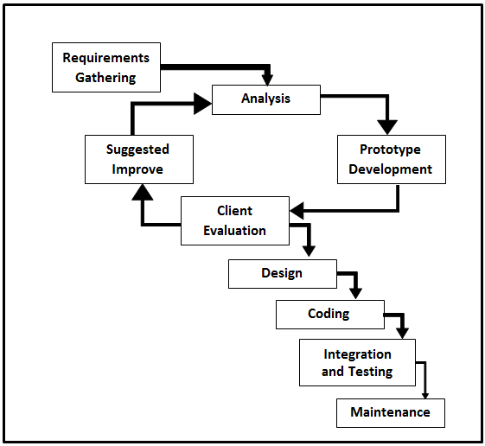

# Figure 2. Evolutionary Prototyping Model

Figure 2 shows the Evolutionary Prototyping Model use in the study. As the device's system is studied, it is followed by the design and development of the machine, which is depicted in this diagram. This way the development of the device will be further improved.

1. **Requirements Gathering.** The current situation was observed during this process in order to gather more information that would guide the development of this project. An interview was conducted, as well as the definition of requirements (user, content, and project requirements) and the development of a project plan. After the proposal has been approved, the analysis phase begins.
2. **Analysis**. The previously developed devices were analyzed during this phase. During this stage, the flaws in the existing devices were discovered. The documented issues were examined in order to provide a general recommendation on how to solve such enhancements or replace the current study.
3. **Prototype Development**. During this phase, the researchers began working on a system that would allow personnel and clients to adapt to changing demands and requirements.
4. **Client Evaluation**. At this point, the management team began to examine and evaluate the system for further areas of concern and improvement.
5. **Suggested Improved.** The researchers began to modify and improve the system that the client had specified. The client reevaluated the system after the researchers assessed its progress to make sure it had improved.
6. **Design.** During this phase, the researchers began to construct the system around the user’s requirements. When the system's requirements were determined, a preliminary or fast design was constructed.
7. **Coding**. In this phase, the researchers began coding using Arduino IDE software that allowed the user to experience or envisage how the system works during this phase.
8. **Integration and Testing.** At this phase, the researchers performed a series of tests to see if the system was functioning properly. The researchers demonstrated how it works to all respondents in order to guarantee that the user's needs were met and any flaws are remedied. Negative testing, unit testing, and acceptance testing were all used by the researchers.
9. **Maintenance**. The system was deployed at this point, and the client assessed its performance. The client also checked to see if there were any issues so that the researchers could address them as soon as possible. The researchers tested the system twice a week to make sure it was working properly.

**Gantt Chart**

The Gantt Chart below depicts the project's development plan and schedule.

# Table 1. Gantt Chart

Legend: Done

Table 1 illustrates a Gantt chart that represents the tasks involved in a project and their order in relation to a schedule. This provides a quick summary of a task, its tasks, and when they must be completed. This shows the allocating resources and planning work around deadlines.

# Requirements Specifications

As part of a research project, functional requirements, user interface, hardware interface, software interface, hardware specification, software specification, safety requirements, and security requirements were being developed. It outlines the project's features, operating environment, design and implementation limitations, concepts, and dependencies in a comprehensive manner. It is also used as a contractual basis for the project's specific characteristics to be completed. This would be carried over to the project's final stage to see if the device met the stated specifications.

**Functional Requirements**

This section describes how a project's or its component's function, where a function is defined as a definition of how inputs and outputs should behave. Use cases capture such behavioral requirements, which describe all of the manifestations in which the device uses the functional requirements. It specifies the requirements for the fundamental processes of the developed device to respond to inputs and produce expected output.

**Table 2. Functional Requirements of the Project**

|  |  |
| --- | --- |
| **Features** | **Description** |
| 1. Coin Counter | Increment credits being inserted to reach the required amount. |
| 2. Display prices and credits | Displays the credits and prices to the LCD to monitor the process of the machine. |
| 3. Dispense Seeds | Dispense the selected seed with the use of push buttons after reaching the required amount. |
| 4. Coin Change | Dispenses the change after a purchased transaction completed with the push of a button. |
| 5. SMS update price | Updates prices of each seed container with the used of confidential code of text messaging. |
| 6. SMS Notifications | After the purchased of the customer is completed, the machine immediately sends an SMS notification of the remaining item and the total sales transaction |
| 7. Power outage free | Protects the machine from unexpected power outage and delayed transaction which utilized Uninterrupted Power Supply (UPS). |
| 8. Light Indicators | The light also indicates the status or process of the machine whether it dispenses seed and when it is ready for another transaction. |
| 9. EEPROM | Stored and remember the recent changes of prices of seeds. |

Table 2 shows the expected particular functional

needs of the already completed project. It was usable by the general public after all of the stated functions were successfully integrated and put into place.

**User Interface**

The interaction between the user and the device, particularly the use of input and output devices. It contains the developed device's actual user interface.

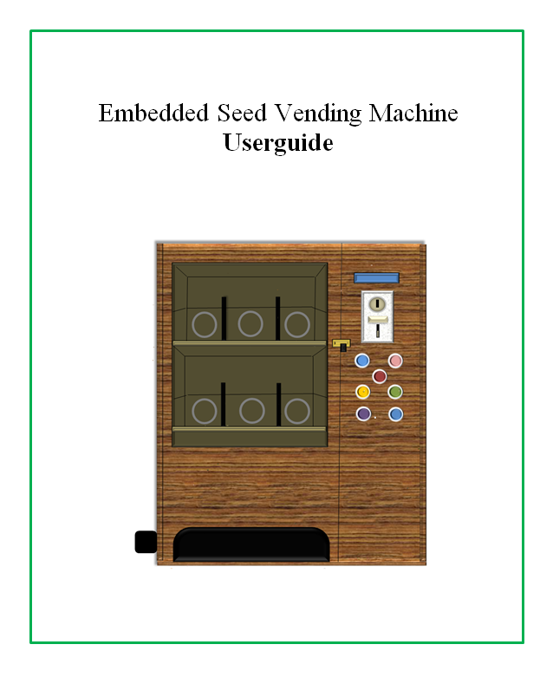

**Figure 3. User Interface of the Project**

Figure 3 shows the machine interactive interface to vending customers as well as the store management, that meet their expectations and support the effective functionality, this facilitates the effective interaction between people involved on the store in terms of aiding transactions. The vending customers interacted by using small screen display to monitor changes of the machine at the same time the coin sensor which they pay for the amount of transaction being process. Before building the entire prototype, the device's appearance was carefully planned using the sketch up tool to guarantee that the device has a good overall appearance.

# Hardware Interface

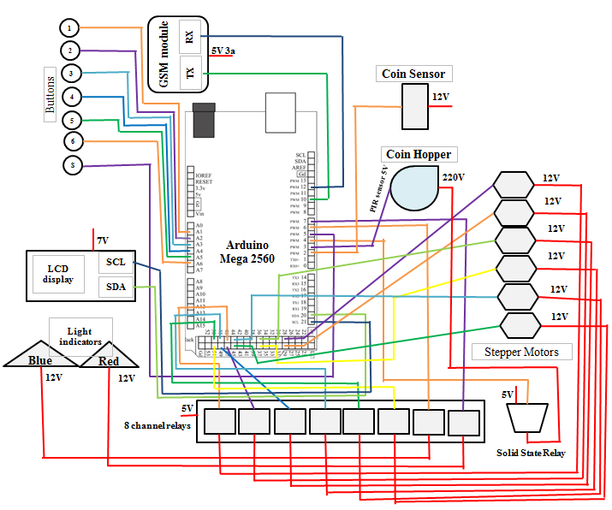 The hardware interface covers the materials and components that make up the project. It also details the logical and physical properties of the device's hardware components. The researchers believed that the hardware utilized in this study complied with the requirements for developing such a machine.

**Figure 4. Schematic Diagram**

Figure 4 shows the schematic diagram method used in device development. The figure illustrates the circuit requirement and pattern for the device. There are six buttons for each container which is button 1, button 2, button 3, button 4, button 5, and button 6. GSM module TX pin attached to digital pin 10 of RX pin of Arduino and RX pin of GSM module attached to digital pin 12 of TX Arduino. Coin sensor signal pin attached to digital pin 2. LCD pin SCL attached to analog pin 4, SDA attached to analog pin 5. Stepper motor signal pins are attached to IN1, IN2, IN3, IN4, IN5, IN6 of Arduino mega digital I/O pins and its power supply connector are interrupted by 8 channel relays to prevent excessive amount of heat that causes damage and over power consumption.

**Software Interface**

# The software was created using the Arduino IDE, and

# uploaded it to Arduino, which clearly indicates the device actions to follow. Arduino IDE is an open-source software designed by Arduino.cc that is used to write, compile, and upload code to practically all Arduino Modules. This software was mainly used by the researchers to develop the program demand for all components functions. The mobile SMS is also used platform to monitor the status of the machine.

# 

# Figure 5. Mobile SMS

# Figure 5 shows the software interface or mobile SMS use to monitor and update prices. This platform was available for almost all of the mobile phone devices. This was where the admin side configures the specific codes for updating the prices for each container.

# Communication Interface

# The device comprises text messaging component notification capabilities, allowing store staff to keep track of the remaining item and total sales of the vending machine. This also allows the administrator or staff to update seed prices using the confidential SMS code. SMS is the based platform of communication between the store staff and the machine.

**Security Requirements**

The researchers first determined what a security need is before deciding whether or not the system is secure. Only authorized persons have access to the system, according to the researchers. Admin can utilize a regular lock or physical lock and the used of SMS messaging service component. The system can be accessed by the administrator and the developer.

**Technical Background**

Technological background gives crucial information regarding the project's technical aspects. It is easier to define what is required in terms that coders can comprehend. The next sections go over the hardware and software specifications.

**Hardware Specifications**

This section lists several hardware along with comprehensive specifications. These particular details are based on the measurements, capacities, operating voltages, and features. The hardware required to complete this project is employed for this project complies with the necessary criteria.

**Table 3. Hardware Specifications**

|  |  |  |
| --- | --- | --- |
| **Components** | **Minimum Specification** | **Recommended Specification** |
| Processor | Pentium CPU, 2GB RAM | Intel Core i3 10th gen,4GB RAM up. |
| Arduino | Uno | Mega 2560 |
| GSM module | Sim800l, 3.4V to 4.4V,1Amp | Sim800l V2, 5V 2Amp |
| Coin-Hopper | Mechanical sensor | PIR sensor |
| Relays | Mechanical | Solid state |
| DC Power supply | 12V 5Amp | 12V 10Amp |
| AC Power Supply | 220V AC | 220V AC |
| UPS | 650VA | 650VA |
| Coin Senor | Universal Coin Slot | Allan Universal Coin Slot |
| DC Motor | MG995 Servo | 28BYJ-48 stepper motor |
| Helical Coils | 14 cm thick copper wire, 15 to 10 slots | 14 cm thick copper wire,15 to 10 slots |
| LCD | 16 x 2 | 16 x 2 |
| DC-DC Buck Converter | LM2596 | LM2596 with seven segments |
| Capacitor | 470uf | 470uf |

Table 3 shows the minimum and recommended hardware specification use in the study. This regards to the features of the development of the project, the machine works as the above component’s specification. The researchers carefully study each component function before integrating it one by one.

**Software Specifications**

Software specifications relate to specified requirements of software used in the creation method of this research. Knowing the minimal and recommended requirements of a piece of software is essential for error-free, seamless use.

**Table 4. Software Specifications**

|  |  |  |
| --- | --- | --- |
| **Component** | **Minimum**  **Specification** | **Recommended**  **Specification** |
| Operating System | Windows 7 Ultimate 32 bit | Windows 10 64 bit |
| Arduino IDE | Arduino 1.8.8 | Arduino 1.8.19 |
| Disk Space | 1 GB | 10 GB |

Table 4 indicates the software specifications for the researchers' software. The researchers used the operating system to run the rest of the program. Researchers also used Arduino IDE, particularly Arduino IDE version 1.8.8.

The researchers also utilized a great amount of storage.

**System Analysis and Design**

The researchers analyzed the capability of managing the store with the use of human interventions and the use of vending machine. Some store believes vending machines are an excellent way to boost customer's satisfaction. One of the key benefits of providing vending machines rather than round-the-clock establishments is that they are less expensive and take up less room. Most businesses desire a vending machine that is not only convenient for their employees and customers, but also for their business. Installing a vending machine in your workplace has advantages for both your company and your employees.

**System Overview**

The project developers carefully planned and crafted the structure operations of project. Its main goal is to create a convenient vending machine that sells seed, specifically for La Luce Feeds Supply, an agricultural store, where the machine will be useful. The device's entire operation is powered by a UPS (uninterruptible power supply). Uninterruptible Power Supply (UPS) devices make devices safe and operable during power surges and breakdowns. When the flow of electricity dips to an inadequate voltage or ceases, an Uninterruptible Power Supply (UPS) provides battery backup power. As the vending customer interact, the agricultural customer is required to place the required coin in the machine corresponding to the product desired or to buy and also the button for it, then the seed or item inside the machine will automatically drop or dispense then the customer can pick it up at the bottom of the machine hole. The customer can also retrieve the rest of its dropped coin or change through the coin-hopper embedded inside the machine. After the customer purchases, the vending machine immediately sends SMS notifications to the admin of the remaining seeds or items in each container and at the same time SMS notifications of the total sales of the machine. Prices per container of seeds can also be updated via SMS in the mobile phone of admin. The code was examined, compiled, and uploaded to the Arduino successfully. Various testing processes were used to thoroughly examine and verify the functionality of the software. Once the desired outcome has been achieved, the project is approved for deployment where our valued client and expected users will utilize it.

**System Architecture**

This section of the study displays the specific structures concerning the flow of system functions, and the completion of tasks in order for progress to be made. A system's structure, behavior, and other aspects are all defined by its conceptual model, or system architecture.

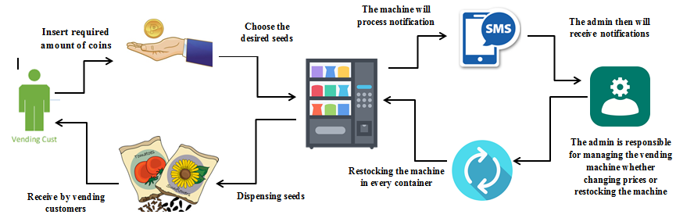

**Figure 6. System Architecture**

Figure 6 shows the system architecture method use in device development. The figure illustrates the architecture requirement and flow pattern for the device. The machine received an output if the customer inserted an amount or credit, after insertion of required credits, the customer purchased the desired item by pushing the designated button for its chosen item, on the other hand, immediately after the customer transaction, the machine processes and sends the SMS notification of remaining item and sales to the administrator to monitor and also configure the machine if changes of prices is needed. The SMS notification of GSM module helps the admin whether the machine is in need for the event of restocking. The SMS notification of total sales will also notify the admin after the purchased transaction is already made; the machine creates an SMS inventory of daily sales.

**Use Case Diagram**

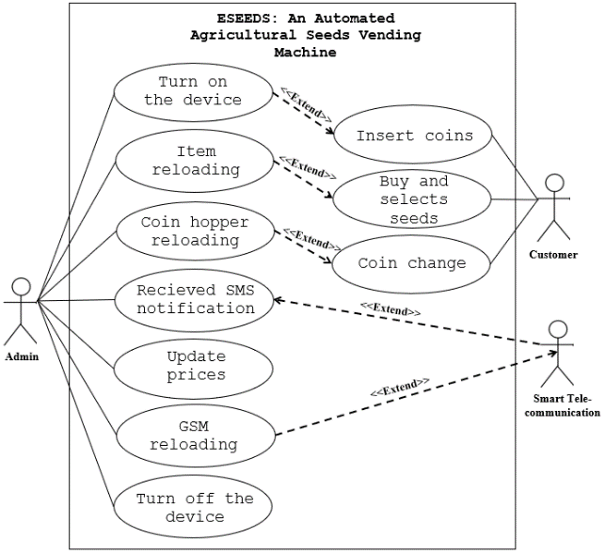 This section depicts the graphical layout of how the first and secondary actors can interact with the project's function and scopes.

**Figure 7. Use Case Diagram of the Project**

The overall usage of the designed project is depicted in Figure 7. The staff is in charge in maintaining and managing the project functions as indicates above figure. While the customers take and the make purchased transaction from the machine. The service provider which is the smart telecom provides SMS service to the project’s SMS notification. It consists of the project's administrator, customer, and service provider. The project's mobile SMS interface will be accessible only to developers and staff.

**Activity Diagram**

This section shows the coordinated activities in order

to carry out the project's intended service. A workflow graphical representation of step-by-step activities and actions with support for choice, iteration, and concurrency

This explains the steps involved in carrying out the machine's activities. It begins in the initial state and ends in the final state, which is similar to how flowchart diagrams work. Activity diagrams are graphical representations of workflows of sequential activities and actions that allow for selection, iteration, and concurrency. Activity diagrams in the Unified Modeling Language are intended to model both computational and organizational processes.

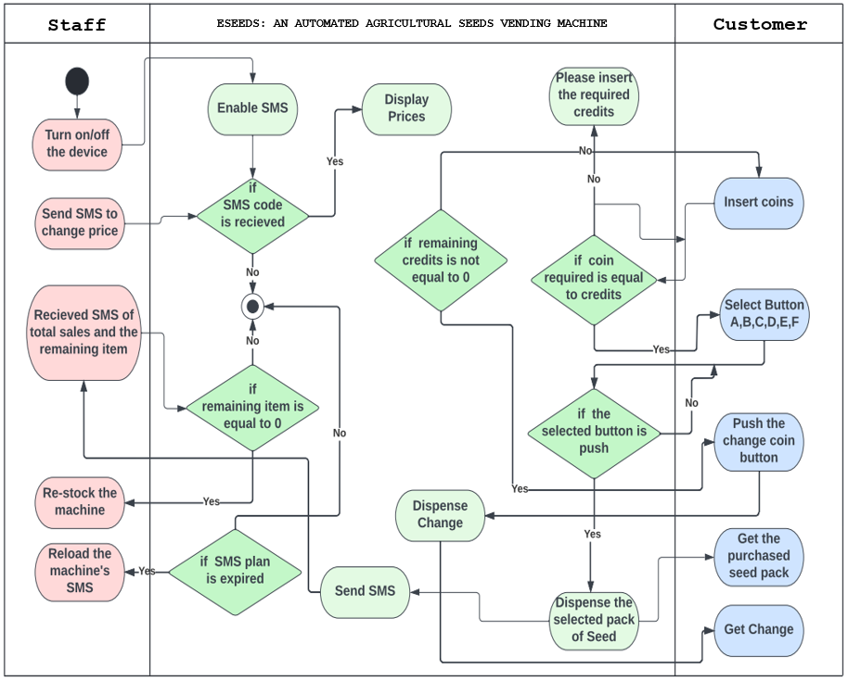

**Figure 8. Activity Diagram**

The vending machine activity diagram is shown in Figure 8. The dedicated activities or execution of the staff, machine, and customer can be easily distinguished and grouped together with different outcomes depending on the path taken through each transaction.

**Data Flow Diagram (DFD)**

A data flow diagram is similar to a map that depicts the flow of information for any system/project process. The context diagram and diagram 0 are described from here.

**Context Diagram**

This section depicts the interaction of the project, actors, as well as outside factors This stands for the overall view of the project and external entities.

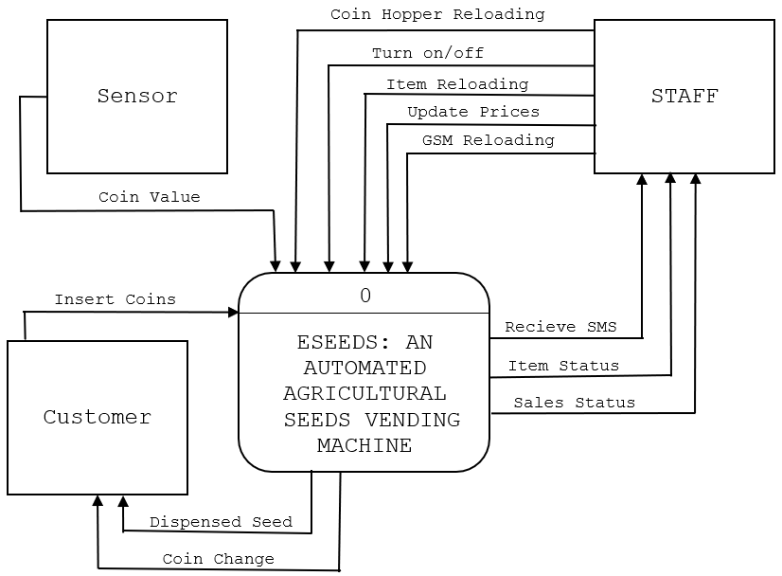

**Figure 9. Context Diagram**

The context diagram for project seed vending machine is shown in Figure 9. The entire project is shown in a single process. The data flowed between the project seed vending machine and other entities including staff, customer and sensor**.** A vision document's context diagram is a simple diagram that depicts the source systems. Data flow was depicted between project and external entities.

**Diagram 0**

This section presents the level 1 or diagram 0 that

is frequently referred to as an "exploded view" of the context diagram, which displays the precise steps involved in how the project operates.

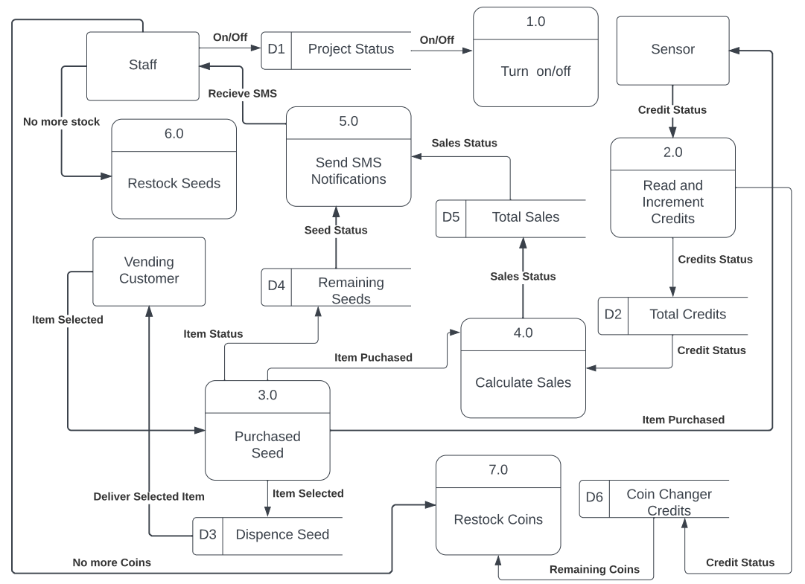

**Figure 10. Diagram 0**

The project's diagram 0 is depicted in Figure 10.

This diagram represents the project's insight perspective, internal processes, dataflow, data external entities and storage. Flow of functions of the project is shown above.

**Database Schema**

A database is a set of linked data that is structured and stored and accessed electronically. This phase showed the features of the existent entities in the project. Existing entities are made accessible to the admin in this way.

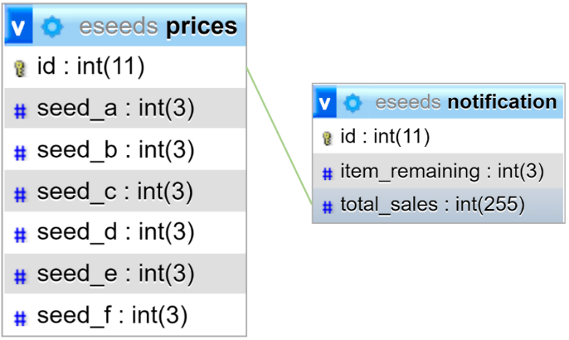

**Figure 12. Database Schema**

Figure 12 shows the connection of entities and its relation. The figure shows the relationship of the table notification and table prices.

**Testing And Evaluation**

The device was tested several times and the key findings were evaluated. Based on the findings, it was determined whether there was anything to improve or change. Testing is extremely beneficial in assessing and analyzing the device's functionality. The device was tested for both its software and its electronic hardware. The researcher developed the project with the aim of assessing the system's performance and outcomes using ISO 25010. The following are the implementation characteristics. The functional suitability,

reliability, performance efficiency, usability, security,

compatibility, maintainability and portability.

**Table 5. Survey Questionnaire**

|  |  |  |  |  |  |
| --- | --- | --- | --- | --- | --- |
| 1. Functional Suitability | 5 | 4 | 3 | 2 | 1 |
| * 1. Functional Completeness. The device performs as expected.   2. Functional Correctness. The device gives accurate results and works without any issues.   3. Functional Appropriateness. The device complies with relevant legal norms or regulations.   4. As a whole. |  |  |  |  |  |
| 1. Reliability |  |  |  |  |  |
| * 1. Maturity. The device works for a long time without crashing or causing service interruptions. |  |  |  |  |  |
| 2.2 Availability. The device is capable of coping with and recovering from component and environmental failures. |  |  |  |  |  |
| 2.3 Fault Tolerance. Even if the device  fails, it can revive and restored to full functionality. |  |  |  |  |  |
| 2.4 Recoverability. The device is capable on  having another way to collect data when  interruption occurs. |  |  |  |  |  |
| 2.5 As a whole |  |  |  |  |  |
| 1. Performance Efficiency |  |  |  |  |  |
| * 1. Time Behavior. When performing its functions, the device has an impact on response and processing times, as well as throughput rates. |  |  |  |  |  |
| * 1. Resource Utilization. The device just requires a small amount of time computing capabilities.   2. Capacity. The device adheres to the efficiency requirements or convention.   3. As a whole. |  |  |  |  |  |
| 1. Usability |  |  |  |  |  |
| * 1. Appropriateness Recognizability. The device's function is simple to comprehend. |  |  |  |  |  |
| * 1. Learnability. The device is simple to use. It does not necessitate any effort on the part of the user.   2. Operability. The device has the ability to make it easy to operate and control.   3. User Error Protection. The device has comprehensive instructions.   4. User Interface Aesthetics. The device |  |  |  |  |  |
| * 1. user friendly.   2. Accessibility. The device is capable of delivering notifications through SMS and can manage through SMS.   3. As a whole. |  |  |  |  |  |
| 1. Security |  |  |  |  | |
| * 1. Confidentiality. The machine ensures the data are accessible only to those authorized to have access |  |  |  |  | |
| * 1. Integrity**.** The machine has a physical lock and only the authorize person have access to its confidential communication number.   2. Non-repudiation.The device can be demonstrated to have worked, making the events or actions permanent.   3. Accountability.Unauthorized users' actions can be tracked back using the device.   4. Authenticity. The device has a specific code that only authorize person can access.   5. As a whole. |  |  |  |  | |
| 1. Compatibility |  |  |  |  | |
| * 1. Co-existence. The device can aid customers as well as the store without negatively impacting any other products. |  |  |  |  | |
| * 1. Interoperability. The device components are able to exchange information through specific communication and use them.   2. As a whole. |  |  |  |  | |
| 1. Maintainability |  |  |  |  | |
| * 1. Modularity. The device has the ability to maintain its functions in different way when encountering failure. |  |  |  |  | |
| * 1. Reusability. Device changes can be managed by the device.   2. Analyzability. The device can be easily recognizing its faults or deficiencies.   3. Modifiability. The device obtains less effort for necessary modification, fault removal or environmental failure.   4. Testability. Verifying or testing a device change requires less effort.   5. As a whole. |  |  |  |  |  |
| 1. Portability |  |  |  |  |  |
| * 1. Adaptability. Changes in device requirements, such as new specifications, operations, operating environments, or upgrades, are easily accommodated by the device. |  |  |  |  |  |
| * 1. Installability. The device met all of the industry's requirements.   2. Replaceability. Within a specific situation, the device enables for easy swap of a certain software/hardware component.   3. As a whole. |  |  |  |  |  |

**Functional Suitability.** This represents the degree to which the system's functions provided the necessary needs and outcomes when performing its tasks.

**Reliability.** Refers to how well the system performed under specific conditions, despite any failures or issues, as well as how consistently it performed.

**Performance Efficiency.** Refers to how well the system uses resources when subjected to certain constraints.

**Usability.** This reflects how effectively the system was used to achieve a goal in a timely and efficient manner.

**Security.** This relates to how well the system protected user data and managed to reduce data vulnerability.

**Compatibility.** Refers to how well the system can run the hardware or software components while performing the required functions.

**Maintainability.** This specifies how well the system can adapt to changes and maintain its core functions before and after various degrees of modification.

**Portability.** Refers to how well the system can run and adapt in different software, hardware, and installation environments, as well as any other forms of transfer.

**Likert Scale**

The researchers used validated survey questionnaires to acquire the needed evaluation of the respondents. Likert scale-type questionnaire was adopted: 5- Very Effective, 4- Effective, 3-Moderately Effective, 2- Ineffective, and 1- Not Effective. It is a psychometric scale that is commonly used in questionnaire-based research. It is the most commonly used approach to scaling responses in survey research, and the terms are frequently used interchangeably with rating scale, despite the fact that there are other types of rating scales. A scale can be created by simply summing or averaging questionnaire responses across a set of individual items.

# Table 6. Likert Scale

|  |  |  |
| --- | --- | --- |
| **Numerical Value** | **Statistical Limit** | **Verbal Description** |
| 5 | 4.50-5.00 | Very Effective |
| 4 | 3.50-4.49 | Effective |
| 3 | 2.50-3.49 | Moderately Effective |
| 2 | 1.50-2.49 | Ineffective |
| 1 | 1.00-1.49 | Not Effective |

# The researchers utilized a five-point Likert scale to analyze the results, as shown in Table 6. Based on the statistical limitations, the numerical values have their own verbal interpretations.

**Implementation Plan**

An implementation plan is a project management tool that helps the project execute a strategic plan by breaking down the implementation process into smaller steps and defining the timeline, teams, and resources required. Implementing the project how you begin your journey toward achieving your goals and eventually arriving at your destination. Before the developed project was deployed, an activity for implementation was created. It served as a guide for the client, who will be in charge of updating and maintaining the project's functionality.

# Table 7. Implementation Plan

|  |  |  |  |
| --- | --- | --- | --- |
| **Activities** | **No. of**  **Days** | **Start Date** | **End Date** |
| Discussion with  user | 1 | 09/04/2021 | 09/04/2021 |
| Deployment Letter | 1 | 10/06/2021 | 10/06/2021 |
| Device Deployment and monitoring period | 31 | 10/08/2021 | 11/08/2021 |
| Device evaluation | 31 | 10/08/2021 | 11/08/2021 |

Table 7 shows how the researchers implemented the activities they recommended to users who chose to use the developed device. There is a list of activities along with the number of days they were carried out. The number of days is determined by the start and finish dates of the activities. It will serve as a guide for the client and for the developers, which will also serve as a timeframe of every task to be accomplished. The scheduled date must be strictly followed. The implementation plan will serve a project schedule for the deployment period, as the execution follows. The project will be implemented to the projected time manner.

**Chapter IV**

**RESULTS AND DISCUSSION**

This chapter presents the design process for the device. It shows the various designs that were used. It also presents the testing and implementation plan for the device. This chapter also contains the results and discussion of the development and testing.

**Presentation of Project Output**

This section shows the developed project output of the study, where customers and admin interface show the actual implementation or use of the device. Each figure displays the description presented and helped the reader to visualize the device as a whole. This regards to the following figures below:

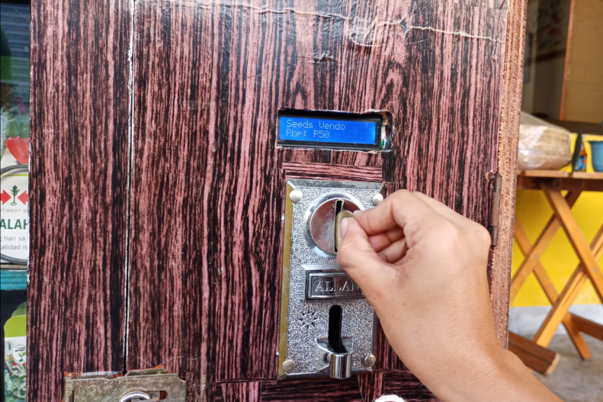

**Figure 13. Insertions of Coins**

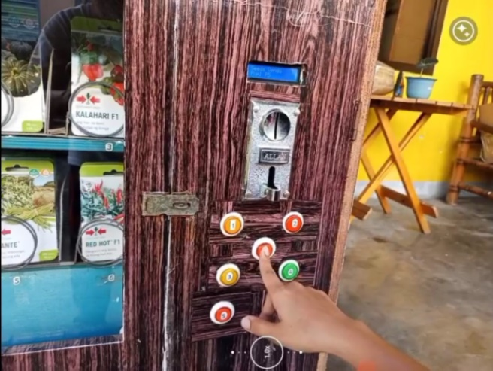 Figure 13 shows the actual insertions of coins in the machine. The universal coin acceptor is used in this project. This allows many customers to insert peso coin one, five and ten denominations.

**Figure 14. Button Selections**

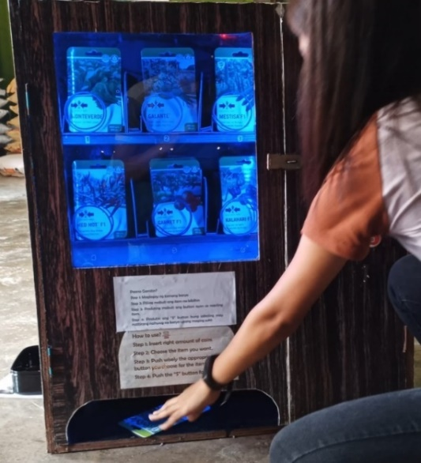 Figure 14 shows the button selections and the change button. It shows the allocated buttons for each container. This allows customers to choose or select items accordingly.

**Figure 15. Dispensed Seed Pack**

Figure 15 shows the actual dispensed pack of seed or item. The customer must monitor if the item is already dispensed. The dispensed area is located in the bottom front of the device.

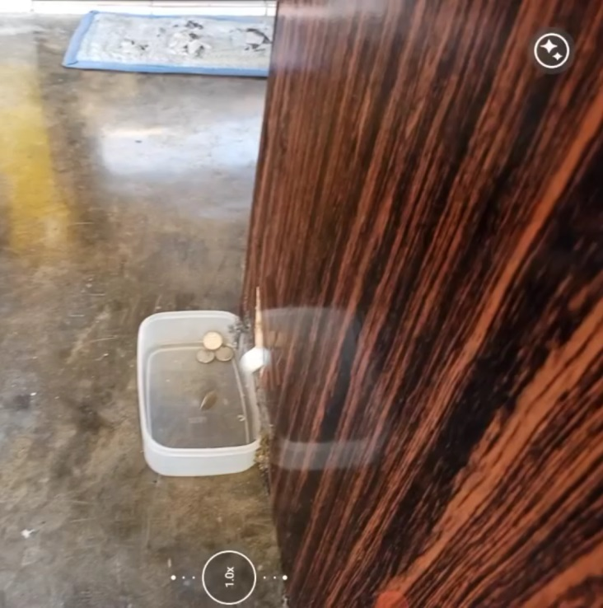

**Figure 16. Coin Change**

Figure 16 shows the actual dispensing of change coins from the purchased item. If the customer has remaining credit, it can be retrieved by pushing the button ‘S”. This also allows customers to retrieve unexpected inserted excess credits.

The Coin changer function utilized a coin hopper which uses a PIR sensor that counts and detects moving object. The coin hopper only counts and dispensed one-peso coins at a time, this means that it is prohibited to reload much higher denomination like five and ten pesos.

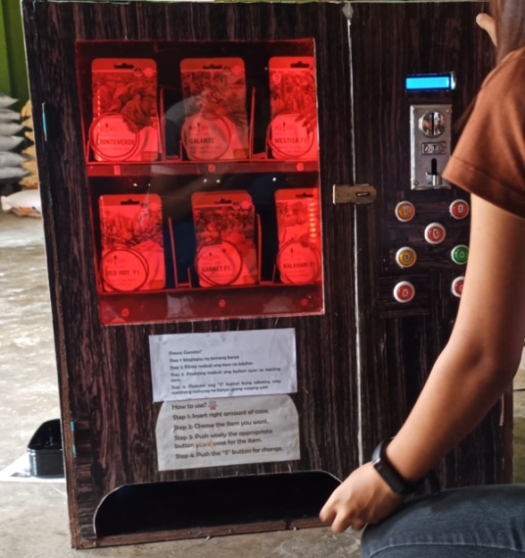

**Figure 17. Red Light Indicator**

Figure 17 shows the red light that indicates for delays that the machine is not ready yet for another transaction. This event is the process where the item is already dispensed. This is also the indicator where the machine is in process of sending SMS notification to the admin.



**Figure 18. LCD Standby Mode**

Figure 18 shows the LDC display standby mode of the machine that displays the item prices. This let the customers to see the prices for each item. This also helps the admin in updating prices easily. The LCD (Liquid Crystal Display) on the Arduino is a form of display that runs on liquid crystals. On the LCD, the characters will be shown.

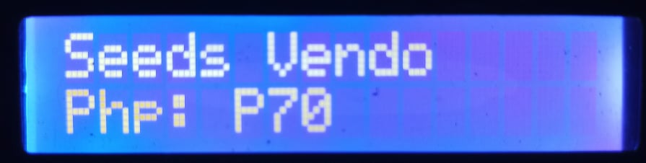

**Figure 19. Inserted Credit Display**

Figure 19 shows the amount of credit being inserted. This let the customers monitor the inserted credit. This displays the increment value of inputted or inserted credits.



**Figure 20. Delivering and Remaining Credits Display**

Figure 20 shows that the vending customer already decided the desired item they want. This is also the LCD display of its status and its remaining credits. This also indicates that the customer has already purchased an item.

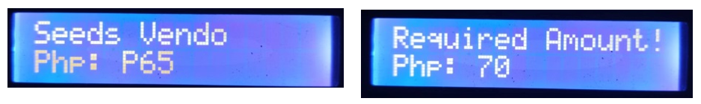

**Figure 21. Requiring Amount**

Figure 21 shows the insufficient number of credits inserted. If the vending customer didn’t insert the right number of credits this will be displayed. This also reminds the customers about the prices of item they are purchasing.

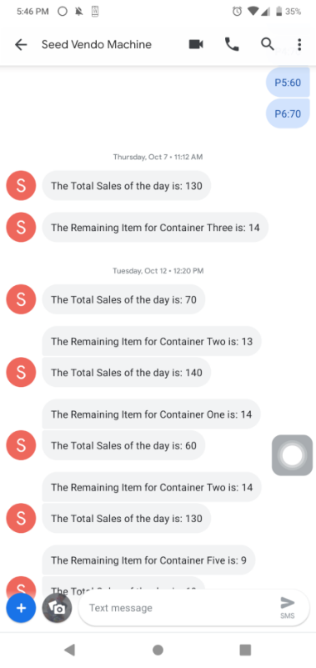

**Figure 22. Mobile Communication Admin Interface**

Figure 22 shows the SMS communication between the machine and the admin, where the admin received SMS notifications of the remaining items of each container and followed by the notification of the total sales transaction. This interface is also used for changing or updating prices of each container containing variety of seeds. The SMS mobile platform is available for almost any mobile devices. The smart telecommunication is the service provider use in the project.

**Evaluation of the Project**

An evaluation of the device's quality standard was undertaken using ISO 25010 criteria in terms of functional suitability, reliability, performance efficiency, usability, security, compatibility, maintainability, and portability as part of the device's implementation plan. This was evaluated by IT experts, the owner, staff, and other participants, as well as customers of the developed project.

**Table 8. Functional Suitability of the Project**

|  |  |  |  |
| --- | --- | --- | --- |
| **Functional Suitability** | **Mean** | **Rank** | **Verbal Interpretation** |
| 1.1 Functional Completeness**.** The device performs as expected. | 4.42 | 1 | Effective |
| 1.2 Functional Correctness**.** The device gives accurate results and works without any issues. | 4.21 | 4 | Effective |
| 1.3 Functional Appropriateness. The device complies with relevant legal norms or regulations. | 4.23 | 3 | Effective |
| 1.4 As a whole**.** | 4.39 | 2 | Effective |
| **Overall Mean:** | **4.31** |  | **Effective** |

Table 8 shows the results of evaluation of the users, regarding the functional suitability of the project, including staff, the owner, customers, IT experts, and others. Based on the ranking, question number one gathered the highest mean, indicating that the device functions appropriately in accordance with its specified features. The responses of the respondents are summarized with an overall mean of 4.31, or can be classified as "effective."

**Table 9.** **Reliability of the Project**

|  |  |  |  |
| --- | --- | --- | --- |
| **Reliability** | **Mean** | **Rank** | **Verbal Interpretation** |
| 2.1 Maturity. The device works for a long time without crashing or causing service interruptions. | 4.6 | 5 | Effective |
| 2.2 Availability. The device is capable of coping with and recovering from component and environmental failures. | 4.40 | 1 | Effective |
| 2.3 Fault Tolerance. Even if the device fails, it can be revived and restored to full functionality. | 4.34 | 3 | Effective |
| 2.4 Recoverability. The device is capable on having another way to collect data when interruption or failure of notification occurs. | 4.14 | 4 | Effective |
| 2.5 As a whole. | 3.92 | 2 | Effective |
| **Overall Mean:** | **4.28** |  | **Effective** |

As shown in table 9 in terms of reliability, the project

was rated effective with an overall mean of 4.28. This indicates that the project has the capacity to continue operating and to withstand any adverse circumstances.

The first-place statement in the ranking is question number two. "The device is capable of coping with and recovering from component and environmental failures," shows that the project is fully operational, can perform its services, and can manage to recover in the event of an environmental failure, and users can rely on its services.

**Table 10. Performance Efficiency of the Project**

|  |  |  |  |
| --- | --- | --- | --- |
| **Performance Efficiency** | **Mean** | **Rank** | **Verbal Interpretation** |
| 3.1 Time Behavior. When performing its functions, the device has an impact on response and processing times, as well as throughput rates. | 3.91 | 3 | Effective |
| 3.2 Resource Utilization. The device just requires a small amount of time computing capabilities. | 4.4 | 1 | Effective |
| 3.3 Capacity. The device adheres to the efficiency requirements or conventions. | 4.0 | 2 | Effective |
| 3.4 As a whole. | 3.80 | 4 | Effective |
| **Overall Mean:** | **4.03** |  | **Effective** |

The evaluation's findings regarding the project's performance are displayed in Table 10. The project's performance received a rating of 4.03, or effective, as can be seen in the table above. This shows how effectively the initiative is carrying out its objectives. When performing its functions, it has a significant impact on response and processing times as well as throughput rates. It is also effective when the norms or conventions linked to the project's efficiency are followed. It suggests that the respondents are satisfied with the project's performance.

The entire list of components under "Performance Efficiency of the project were deemed successful. The rating followed the same top-to-bottom order as the various claims. To sum up, the overall assessment was successful and demonstrates that the project is effective at performing tasks that are simple for people to utilize. It also demonstrates that the project could continue to fulfill its activities under specific circumstances and accommodate multiple and parallel inquiries. The results of evaluation of the users, regarding the functional suitability of the project, including staff, the owner, customers, IT experts, and others. Based on the ranking, question number two gathered the highest mean, indicating that the device is efficient in accordance with its specified features and achieved its objectives. It implies that the device can continue to perform its efficient delivery of its service.

**Table 11. Usability of the Project**

|  |  |  |  |
| --- | --- | --- | --- |
| **Usability** | **Mean** | **Rank** | **Verbal Interpretation** |
| 4.1 Appropriateness Recognizability. The device's function is simple to comprehend. | 4.37 | 5 | Effective |
| 4.2 Learnability. The device is simple to use. It does not necessitate any effort on the part of the user. | 4.04 | 7 | Effective |
| 4.3 Operability. The device has the ability to make it easy to operate and control | 4.71 | 1 | Very Effective |
| 4.4 User Error Protection. The device has comprehensive instructions. | 4.57 | 4 | Very Effective |
| 4.5 User Interface Aesthetics. The device user friendly. | 4.64 | 3 | Very Effective |
| 4.6 Accessibility. The device is capable of delivering notifications through SMS and can manage through SMS. | 4.06 | 6 | Effective |
| 4.7 As a whole. | 4.66 | 2 | Very Effective |
| **Overall Mean:** | **4.56** |  | **Very Effective** |

According to table 11, the respondents gave it a usability rating of 4.56, or very effective. This essentially indicates that the project is simple to use and highly usable. Additionally, this initiative can meet consumers' demands in a way that makes their health a consideration. Use of the project does not necessitate technical expertise or in-depth learning efforts on the part of various user categories. This suggests that the device is simple to use and understand.

The overall operability of the project under the usability ranks first. It is followed by the statement number 4.7 and 4.5 which is all about being user friendly. However, the appropriateness recognizability was rated by the respondents with an overall mean of 4.37 or effective. The project learnability on which the users can adapt and comprehend any instructions, as the respondents gave rating of effective with an overall mean of 4.04. The project user error protection on which the device reminds the users to read instructions that gathered an overall mean of 4.57 or very effective. With an overall mean of 4.06 or effective, the project's accessibility comes in sixth place, making it suitable for all users. Usability is the evaluation of a product or system's appropriateness in terms of recognizability, learnability, operability, user error protection, user interface aesthetics, and accessibility in order to meet defined goals effectively, efficiently, and satisfactorily**.**

**Table 12. Security of the Project**

|  |  |  |  |
| --- | --- | --- | --- |
| **Security** | **Mean** | **Rank** | **Verbal Interpretation** |
| 5.1 Confidentiality. The machine ensures the data are accessible only to those authorized to have access. | 4.61 | 1 | Very Effective |
| 5.2 Integrity.The machine has a physical lock and only the authorize person have access to its confidential communication number. | 4.29 | 6 | Effective |
| 5.3 Non-repudiation. The device can be demonstrated to have worked, making the events or actions permanent. | 4.56 | 2 | Very Effective |
| 5.4 Accountability. Unauthorized users' actions can be tracked back using the device. | 4.37 | 4 | Effective |
| 5.5 Authenticity**.** The device has a specific code that only authorize person can access. | 4.43 | 3 | Effective |
| 5.6 As a whole. | 4.32 | 5 | Effective |
| **Overall Mean:** | **4.43** |  | **Effective** |

Table 12 shows that in terms of security, the project's performance was given an effective rating of 4.43, indicating that the security of the project ensures that the data is being safeguarded and that no one can easily access it.

This shows that the project successfully makes sure that it can prevents illegal access to or alteration of computer programs or data by limiting access to data to those with the proper authorization. Additionally, it successfully establishes the legitimacy of a subject or source.

As shown in the table the confidentiality-related statement 5.1, which is rated as rank one. This shows that the respondents truly thought the project data is safe and secure.

**Table 13. Compatibility of the Project**

|  |  |  |  |
| --- | --- | --- | --- |
| **Compatibility** | **Mean** | **Rank** | **Verbal Interpretation** |
| 6.1 Co-existence. The device can aid customers as well as the store without negatively impacting any other products. | 4.58 | 1 | Very Effective |
| 6.2 Interoperability. The device components are able to exchange information through specific communication and use them. | 4.37 | 2 | Effective |
| 6.3 As a whole. | 4.32 | 3 | Effective |
| **Overall Mean:** | **4.42** |  | **Effective** |

Table 13 shows the compatibility on which the project received a rating of effective with a 4.42 average mean. This indicates that the project can interact with another software or project without affecting any other end products. This shows that the project can effectively carry out its necessary tasks while utilizing a shared environment and resources without having a negative effect on any other products. Additionally, it can correctly use it and exchange information with other products.

The ability of a product, system, or component to exchange information and perform its required functions while sharing the same hardware or software environment is referred to as compatibility. Interoperability between any two products, including hardware and software, goods of the same or different sorts, and goods of the same or different versions, can be referred to as compatibility. Products that are made to work with upcoming iterations of themselves are referred to as forward compatible; those that are made to work with previous iterations are referred to as backward compatible. Compatibility is the capacity for two systems to work together without having to be altered to do so.

According to the rating, statement number 1 comes in first, which indicates that respondents thought the project was compatible with other programs inside the same product.

**Table 14. Maintainability of the Project**

|  |  |  |  |
| --- | --- | --- | --- |
| **Maintainability** | **Mean** | **Rank** | **Verbal Interpretation** |
| 7.1 Modularity. The device has the ability to maintain its functions in different way when encountering failure. | 4.18 | 6 | Effective |
| 7.2 Reusability. Device changes can be managed by the device. | 4.35 | 3 | Effective |
| 7.3 Analyzability. The device can be easily recognizing its faults or deficiencies. | 4.27 | 4 | Effective |
| 7.4 Modifiability. The device obtains less effort for necessary modification, fault removal or environmental failure. | 4.24 | 5 | Effective |
| 7.5 Testability. Verifying or testing a device change requires less effort. | 4.56 | 1 | Very Effective |
| 7.6 As a whole. | 4.36 | 2 | Effective |
| **Overall Mean:** | **4.33** |  | **Effective** |

In terms of maintainability, as indicated in table 14, the respondents gave the initiative an overall mean of 4.33, rating it as effective. This shows that the project could efficiently adjust to modifications like new requirements, operating conditions, or improvements to system requirements without degrading its functionality. Additionally, it means that less effort will be needed to maintain the project and that the services will continue to be provided. Also, as a result of this, the initiative could identify the underlying causes of failure, manage system modifications, necessitate less effort for environmental or fault correction, and test system modifications quickly.

**Table 15. Portability of the Project**

|  |  |  |  |
| --- | --- | --- | --- |
| **Portability** | **Mean** | **Rank** | **Verbal Interpretation** |
| 8.1 Adaptability. Changes in device requirements, such as new specifications, operations, operating environments, or upgrades, are easily accommodated by the device. | 4.46 | 1 | Effective |
| 8.2 Installability. The device met all of the industry's requirements. | 4.25 | 3 | Effective |
| 8.3 Replaceability. Within a specific situation, the device enables for easy swap of a certain software/hardware component. | 4.19 | 4 | Effective |
| 8.4 As a whole. | 4.44 | 2 | Effective |
| **Overall Mean:** | **4.34** |  | **Effective** |

As shown in the table 15, the project received an overall mean of 4.34, which indicates that it was assessed as effective in terms of portability. This indicates that the project is highly portable, can quickly be implemented, and can efficiently adapt to changes such as new standards, operating guidelines, or upgrades in hardware needs without impairing its operation. Users thought it could suit the needs of the modern technological industry standards. The ability of a system, product, or component to be transported from one environment to another is referred to as portability.

According to the ranking, statement number one ranks first, indicating that respondents believed the project could be successfully installed and uninstalled if the owner wanted to position or carry it anywhere in the store. It does not require much effort to operate and can be placed anywhere in the store. When the developers deployed the device in La Luce Feeds Supply agricultural store, the respondents saw how simple it was to install. During the deployment period, the project developers taught the owner how to install the device, and the manager greatly adapt with the entire process. That is clear evidence that the owner had no difficulties in getting the project up and running. If future researchers want to adapt this project, the Arduino program is portable and requires less effort to make it run on different platforms or Arduino boards. It indicates that the device is simple to set up, adapt to changes, and replace supplied software/hardware components inside a given environment.

**Table 16. Summary Results of the Evaluation**

|  |  |  |  |
| --- | --- | --- | --- |
| **Items** | **Mean** | **Rank** | **Verbal Interpretation** |
| 1. Functionality suitability | 4.31 | 6 | Effective |
| 2. Reliability | 4.17 | 7 | Effective |
| 3. Performance efficiency | 4.6 | 8 | Effective |
| 4. Usability | 4.52 | 1 | Very Effective |
| 5. Security | 4.43 | 2 | Effective |
| 6. Compatibility | 4.42 | 3 | Effective |
| 7. Maintainability | 4.33 | 5 | Effective |
| 8. Portability | 4.34 | 4 | Effective |
| **Overall Mean:** | **4.39** |  | **Effective** |

The results of the overall device evaluation by Customers, Staff, Owner, Others, and IT Expert are shown in Table 16. The project evaluation results, regarding the respondents' assessment of compliance with the ISO 25010 standards. It indicates that they rated the device as "Effective" with the obtained mean of each corresponding variable: functional suitability (M = 4.31), reliability (M = 4.17), performance efficiency (M = 4.6), usability (M = 4.52), security (M = 4.43), compatibility (M = 4.42), maintainability (M = 4.33), and portability (M = 4.34), with the overall mean of 4.39.

**Implementation Results**

This section shows the result of the project implementation based on the implementation plan. The researchers deployed the project on schedule, which allows them to make accurate preparations. The implementation assists researchers in realizing the real-world transaction on which it is first tested and integrated. The implementation results assist researchers in gathering information from respondents. The implementation provides the client and researchers with an outcome that demonstrates the client's value in providing its service. The client will also suggest some improvements. The researchers perform maintenance to ensure the project's dependability. The project is deployed in thirty-one days, which is one month. This section shows the results of activities performed by the researcher during the deployment period.

**Table 17. Results of Project Implementation**

|  |  |  |  |
| --- | --- | --- | --- |
| **Activities** | **Target**  **Date** | **Result** | **Remarks** |
| Discussion with user and client | April 11,  2021 | Researchers had discussions with the users and client. | Some functions were added based on the suggestions of the client. |
| Deployment Letter | October 02, 2021 | Deployment letter was signed at exact date. | None |
| Project deployment and monitoring period | October 06, 2021  to November 07, 2021 | One month deployment was done at exact deployment period. | There is a minor issue that needs to be fixed. |
| Project Evaluation | November 08, 2021 | Before the end date of the project evaluation period, all questionnaires are filled out. | None |

The results of project implementation are shown in table 17. The activities in the implementation plan occur exactly between the start and end dates.

The results of every activity are documented and listed in the column result with remarks. The project developers ensure that all activities are completed in a timely manner.

# Chapter V

**SUMMARY, CONCLUSION AND RECOMMENDATION**

The study's summary of findings, conclusions, and recommendations are presented in this chapter. This section comprises the researchers' observations and interpretations based on the survey results and data that was evaluated and analyzed.

**Summary**

This research paper developed an automated selling technology for various variety packs of east-west seeds products from within the store of La Luce Feeds Supply, with practical and useful features for the agricultural store, where it solves the problem of inconvenient direct interaction, where the store experiencing labor-intensive from many customers, managing sales and customer retention. The researchers used evolutionary prototyping model SDLC. System Development Life Cycle (SDLC) is a series of phases in the device developmental process.

The researchers came to the number of conclusions and observations. The researchers successfully evaluated the device performance using ISO 25010, survey questionnaire is used to gathered data needed for the study. There were 50 total respondents, including the customers, staff, owner, IT experts and others. As the result of the findings, the device verbal interpretation rated as "Effective", with the obtained mean of each corresponding variable: functional suitability (M = 4.31), reliability (M = 4.17), performance efficiency (M = 4.6), usability (M = 4.52), security (M = 4.43), compatibility (M = 4.42), maintainability (M = 4.33), and portability (M = 4.34), with overall mean equal of 4.39, that the device fulfilled the user's requirements in terms of functionality suitability, reliability, performance efficiency, usability, security, compatibility, maintainability, and portability, as showed by the respondents’ good ratings. Based on the gathered data, the device provides a proper feature of automated selling of variety pack of east-west seeds for the agricultural store, the device can generate text messages for timely notifications of remaining seeds of each container from the vending machine with the capacity load of 10 to 15 item each, at the same time it also sends text messages for the update of sales or as transaction records to the admin. It can also be changing its price of each container by the administrator, by using text messages specifically in sending code designated to change the prices in case that the price of the seeds needs to be updated. Environmental risk ready which the transaction is uninterruptible when power outage occurs unexpectedly. It can change coins if the customer has a remaining credit that already been inserted. The researchers successfully developed an implementation plan which has a timeframe of 31 days from October 08, 2021 to November 08, 2021.

**Conclusions**

During the development of the project, the researchers came to a number of conclusions and observations. The following are:

1. The project provides an automated selling of seeds that aid an agricultural store, specifically the La Luce Feeds Supply;
2. The project provides SMS inventory has been created throughout the implementation period of the vending machine by which the number of the remaining item and total sales received by the store staff;
3. The researchers successfully integrated and developed a price change function, as a consequence of which the store staff managed the machine's pricing by sending specified SMS or code text messages utilized in updating prices;
4. The proposed device satisfies the user's requirements in terms of functionality suitability, reliability, performance efficiency, usability, security, compatibility, maintainability, and portability, as indicated by the respondents’ good ratings. As the result of the study, the device verbal interpretation rated as "Effective", with an overall mean equal of 4.39; and
5. For clients who adopt the project, the project provides an implementation plan.

**Recommendations**

The researchers recommend the following based on the device's performance over the course of the deployment period:

1. To the future researchers, it is recommended to increase the dimensions or the body of the machine for more item or seeds to be stored.
2. To the future researchers, the machine might use a bill acceptor to accept paper bills.

# BIBLIOGRAPHY

**Books**

Arifin, S. M. S., Syai'in, M., Endrasmono, J., Sarena, S. T., Subiyanto, L., Setyoko, A. S., ... & Soeprijanto, A. (2017, July). Smart vending machine based on SMS gateway for general transactions. In 2017 15th International Conference on Quality in Research (QiR): International Symposium on Electrical and Computer Engineering (pp. 34-39). IEEE.

Asyhari, M. W., Sigit, R., & Sukaridhoto, S. (2019, September). Vending Machine Monitoring System Integrated with Webserver. In 2019 International Electronics Symposium (IES) (pp. 556-559). IEEE.

Babu, D. V., Subramanian, P., Karthikeyan, R., Akash, N., Phanindra, U., & Hemanth, G. (2020, December). RFID and GSM based Automatic Dispensing and Monitoring of Sanitary Napkin Vending Machine for Menstrual Hygiene among Women. In IOP Conference Series: Materials Science and Engineering (Vol. 993, No. 1, p. 012074). IOP Publishing.

Budiarto, R., Gunawan, N. K., & Nugroho, B. A. (2020, July). Smart Chicken Farming: Monitoring System for Temperature, Ammonia Levels, Feed in Chicken Farms. In IOP Conference Series: Materials Science and Engineering (Vol. 852, No. 1, p. 012175). IOP Publishing.

Baby, C. J., Singh, H., Srivastava, A., Dhawan, R., & Mahalakshmi, P. (2017, March). Smart bin: An intelligent waste alert and prediction system using machine learning approach. In 2017 International Conference on Wireless Communications, Signal Processing and Networking (WiSPNET) (pp. 771-774). IEEE.

Hassan, H., Mazlan, M. I. Q., Ibrahim, T. N. T., & Kambas, M. F. (2020, September). IOT System: Water Level Monitoring for Flood Management. In IOP Conference Series: Materials Science and Engineering (Vol. 917, No. 1, p. 012037). IOP Publishing.

Han-Markey, T. L., Wang, L., Schlotterbeck, S., Jackson, E. A., Gurm, R., Leidal, A., & Eagle, K. (2017). A public-school district's vending machine policy and changes over a 4-year period: Implementation of a national wellness policy. Public Health, 126(4), 335- 337.

Kohei Ushikubo (2018). Automatic vending machines that use only key cards to run. Sanden Holding Corp (USPTO). Publication of US4767917A.

Kanagasabapathi, V., Naveenraj, K., Neelavarnan, V., & Raj, S. N. (2019, March). Automatic chocolate vending machine. In the 2019 5th International Conference on Advanced Computing & Communication Systems (ICACCS) (pp. 584-587). IEEE.

Mulyani, S., & Hartono, R. (2019, November). Vending machines and influence on life in Indonesia. In IOP Conference Series: Materials Science and Engineering (Vol. 662, No. 5, p. 052001). IOP Publishing.

Matthews, M. A., & Horacek, T. M. (2017). Vending machine assessment methodology. A systematic review. Appetite, 90, 176-186.

Qureshi, M. A., Aziz, A., Rasool, H. F., Ibrahim, M., Ghani, U., & Abbas, H. (2017). Design and Implementation of Vending Machine using Verilog HDL. In 2017 2nd International Conference on Networking and Information Technology, IPCSIT (Vol. 17).

Rezwan, S., Ahmed, W., Mahia, M. A., & Islam, M. R. (2018, October). IoT based smart inventory management system for kitchen using weight sensors, LDR, LED, Arduino Mega and NodeMCU (ESP8266) Wi-Fi module with website and app. In 2018 Fourth International Conference on Advances in Computing, Communication & Automation (ICACCA) (pp. 1-6). IEEE.

Solano, A., Duro, N., Dormido, R., & González, P. (2017). Smart vending machines in the era of internet of things. Future Generation Computer Systems, 76, 215- 220.

Tejić, B., Tegeltija, S., Horvat, S., Nićin, M., Stanojević, M., & BABIĆ, M. (2019). Payment Methods in Vending Machines. J. Mechatronics, Autom. Identif. Technol, 4(3), 20-25.

Vishnupriya, K., & Mamatha, N. P. (2019). Health Automatic Medicine Vending Machine. Perspectives in Communication, Embedded-systems and Signal- processing- PiCES, 2(10), 245-247.

Verma, A., Rathore, A. S., & Kumari, A. C. (2018). An automated approach to public distribution system using internet of things. Procedia computer science, 132, 288-296.

Yumang, A. N., Paglinawan, C. C., Paglinawan, A. C., Avendaño, G. O., Esteves, J. A. C., Pagaduan, J. R. P., & Selda, J. D. S. (2017, December). Real-time flood water level monitoring system with SMS notification. In 2017IEEE 9th International Conference on Humanoid, Nanotechnology, Information Technology, Communication and Control, Environment and Management (HNICEM) (pp. 1-3). IEEE.

Yunita, A. S., & Pangaribuan, I. (2019, November). Vending Machine Business as a Solution to Feminine Hygiene Products Necessary. In IOP Conference Series: Materials Science and Engineering (Vol. 662, No. 3, p. 032017). IOP Publishing.

**Journals**

ALFarsi, G., & ALSinani, M. (2017). Developing a mobile notification system for al Buraimi University College students. International Journal of Information Technology, 1(1), 10-16.

Bebe, B. O., Van Der Lee, J., & Kilelu, C. W. (2021). Milk vending machine retail innovation in kenyan urban markets: operational costs, consumer perceptions and milk quality. HSOA Journal of Dairy Research & Technology, 3.

Cardaci, R., Burgassi, S., Golinelli, D., Nante, N., Battaglia, M. A., Bezzini, D., & Messina, G. (2017). Automatic Vending-Machines Contamination: A Pilot Study. Global Journal of Health Science, 9(2), 63.

Kros, J. F., Kirchoff, J. F., & Falasca, M. (2019). The impact of buyer-supplier relationship quality and information management on industrial vending machine benefits in the healthcare industry. Journal of Purchasing and Supply Management, 25(3), 100506.

Navlakha, M., Rathore, L. S., & Sharma, L. (2017). Water Vending Machine. International Journal of Engineering and Management Research (IJEMR), 7(2), 581-584.

Sidik, M., & Ghani, S. C. (2017). Volume measuring system using arduino for automatic liquid filling machine. International Journal of Applied Engineering Research, 12(24), 14505-14509.

Kumar, A., & Kumar, P. (2021). Reliability assessment for multi-state automatic ticket vending machine (ATVM) through software and hardware failures. Journal of Quality in Maintenance Engineering.

Wiyanti, D. T., & Alim, M. N. (2020, June). Automated vending machine with IoT infrastructure for smart factory application. In Journal of Physics: Conference Series (Vol. 1567, No. 3, p. 032038). IOP Publishing.

**Unpublished Materials**

Canino, M. I. C. (2017). Design and implementation of telemetry on an Arduino -based vending machine via SMS.

El-Abd, M. (2017). A review of embedded systems education in the Arduino age: Lessons learned and future directions.

Carter, R. A. (2017). EPRAM: A Risk Analysis and Mitigation Based Evolutionary Prototyping Model for Quality Requirements Development.

Pinili, E., & Ponce, M. (2017). Coin operated coffee vending machine. Department of Electronics and Communication Engineering Negros Oriental State University.

Rishabh Jain (2018). IoT Based Patient Health Monitoring System using ESP8266 and Arduino.

Velasco, J., Alberto, L., Ambatali, H. D., Canilang, M., Daria, V., Liwanag, J. B., & Madrigal, G. A. (2019). Internet of things-based (IoT) inventory monitoring refrigerator using arduino sensor network. arXiv preprint arXiv:1911.11265.

# APPENDIX A

**Project Team Assignments Form**

|  |  |
| --- | --- |
| Team Marduino | ESEEDS: An Automated Agricultural Seeds Vending Machine |

|  |  |  |
| --- | --- | --- |
| **Name and Signature** | **Project Role** | **Email address / Mobile number** |
| Martin Lawrence M. Caringal | Project Manager/ Software Engineer/ Hardware Engineer/ Project Architect | rencecaringal@gmail.com |
| Cristal Joy C. Alferez | System Analyst/ Researcher/ Technical Writer | alferezcristaljoy@gmail.com |

**APPENDIX B**

**Capstone Project Topic Proposal Form**

|  |  |
| --- | --- |
| **Project Title:** | ESEEDS: An Automated Agricultural Seeds Vending Machine |
| **Proponents/ Researchers:** | 1. Cristal Joy C. Alferez 2. Martin Lawrence M. Caringal |
| **Objectives of the Study:** | Generally, this study aimed to design and develop ESEEDS: An Automated Agricultural Seeds Vending Machine for La Luce Feeds Supply store, specifically this study aimed to:  1. Develop an automated selling packs for the variety of east-west seeds;  2. Integrate SMS to notify the administrator for the remaining items and total sales;  3. Incorporate SMS that will allow administrator to monitor and manage prices;  4. Evaluate the developed project performance using ISO 25010;  5. Implement the developed system to the respective client. |
| **Scope of the Study:** | This study was primarily developed for an agricultural store that offers convenient seed selling services to its staff and consumers, such as an automated selling procedure and sales transaction data. The device covers the sale of a variety of seeds to agricultural customers while sending reports on the item's remaining stock and total sales transaction. The admin can restock seeds, update pricing, replenish coins in the coin hopper, reload GSM, and receive SMS notifications of the remaining items and total sales. Agricultural customers can choose and buy different types of seeds packs according to the seeds they want and also according to its price. Customers in the agricultural sector can simply get their change thanks to the project's coin changer and coin retriever, as well as an emergency power supply for the machine in the event of a power outage. |
| **Limitation of the Study:** | The device is limited only to cater agricultural sector in terms of seed sales and its variety. Other agricultural products will not be accepted for sale by the device. The device's item loading capacity is limited, ranging from 10 to 15 items per container. The device only accepts old and new peso coins in denominations of one, five, and ten pesos. The device will not dispense item until required credits are completely inserted. The pricing of the devices can only be specified between 1 and 255. The coin hopper reloading mechanisms can only be set in one peso currency. Only a special admin texting code can be configured for the device's pricing changing feature. The device emergency power supply can last only about one to five hours without charging. |
| **Review of Related Literatures and System** | Matthews, M. A., & Horacek, T. M. (2017) The nutritional quality of food and beverage products sold in vending machines has been implicated as a contributing factor to the development of an obesogenic food environment. How comprehensive, reliable, and valid are the current assessment tools for vending machines to support or refute these claims? A systematic review was conducted to summarize, compare, and evaluate the current methodologies and available tools for vending machine assessment. A total of 24 relevant research studies published between 1981 and 2013 met inclusion criteria for this review. The methodological variables reviewed in this study include assessment tool type, study location, machine accessibility, product availability, healthfulness criteria, portion size, price, product promotion, and quality of scientific practice. There were wide variations in the depth of the assessment methodologies and product healthfulness criteria utilized among the reviewed studies. Of the reviewed studies, 39% evaluated machine accessibility, 91% evaluated product availability, 96% established healthfulness criteria, 70% evaluated portion size, 48% evaluated price, 52% evaluated product promotion, and 22% evaluated the quality of scientific practice. Of all reviewed articles, 87% reached conclusions that provided insight into the healthfulness of vended products and/or vending environment. Product healthfulness criteria and complexity for snack and beverage products was also found to be variable between the reviewed studies. These findings make it difficult to compare results between studies. A universal, valid, and reliable vending machine assessment tool that is comprehensive yet user-friendly is recommended.  Mulyani and R Hartono (2019), to learn more about vending machine business potential and their impact on Indonesian living. Practical items became necessary as the times progressed. Japan is one of those countries that is constantly coming up with innovative ideas in any industry, including sales. A vending machine is one example. This study is influenced by the fact that Indonesia is one of the world's most consumptive countries. The analysis in this study was focused on a theoretical framework, which was a qualitative research approach. Because research focuses on socio-cultural conditions, this research approach is also applied. According to the findings of this study, Indonesia is both a consumer and a producer country that wants high practicality. Therefore, with the existence of this vending machine, how to buy something will be easier, practical and efficient.  Kanagasabapathi, et al. created a machine by someone else (2019) The fundamental goal of the concept is to bring fresh innovative applications to the public's attention. A vending machine that sells a variety of goods. To circumvent the coin-based vending machine that does not restore the balance amount if no change is available, we use Radio Frequency Identification (RFID) and Arduino. Before the RFID is read, the consumer can select the product; when the card is scanned, the product can be collected at the chocolate collector. In the machine, there are three parts, the first of which provides cashless payment via RFID. In the second unit, Arduino UNO completed the programming step, and the machine then delivered the product and presented the information on the display. In a coin-operated vending machine, this study devised a solution to the problem of the machine not returning the balance amount.  Vending machines, according to Asyhari, et al. (2019), are one of the most rapidly evolving technological achievements in the modern period. In Indonesia, there are various vending machines, but no one automatic vending machine vendor who sells medical devices and checks inventory and transactions using manual techniques by checking directly into the vending machine. The purpose of making a vending machine that is integrated with web servers is expected to be able to be provided by machine working suppliers and to see the number of transactions that have been entered online. Everyone can use a vending machine integrated with this webserver. To buy the desired product, the consumer must pay by entering the agreed banknotes and then replacing the desired product button and the machine will issue the product that the customer wants. After the machine issues the product, the manufacturer's personal computer (PC) will communicate data to the web server so that transactions that have already been entered can be completed. The system has an 80% success rate in dispensing items, 100% shipping the amount of data 100 with the average time required by the system to receive 2455.05 ms, and 98 percent shipping the amount of data 300 with the average delivery required by the system to 2455.05 ms. The system took an average of 7263.70 milliseconds to receive 5845.14 milliseconds, accounting for 68% of the delivery of 500 data.  John K,et.al 2019) Industrial vending machines (IVM) can help healthcare organizations address inventory management issues. Grounded in transaction cost economics and contingency theory, this research develops and empirically tests a model that highlights the critical role of information management in the link between buyer-supplier relationship quality and performance outcomes within the context of IVM implementation and use in the healthcare industry. Based from the author Rishabh Jain (2018) an IoT based Health Monitoring System which records the patient heart beat rate and body temperature and also send an email/SMS warning whenever those readings go beyond critical values. Pulse rate and body temperature measurements are registered over ThingSpeak and Google sheets so that patient wellbeing can be tracked from anywhere in the world over the internet. A panic will also be attached so that the patient can press it on emergency to send email/sms to their relatives.  Verma, A., et.al (2018) SMS (Short Message Service) is currently the most profitable data service for mobile operators. While SMS has traditionally been used for person-to-person messaging, application-to-person services have grown in popularity in recent years. The incorporation of SMS notification functions into web applications would take mobility to a new stage, combining the benefits of the Internet and Mobile Technologies. The SMS Service created allows any web application to send short messages to mobile phones of up to 160 characters. Using a combination of open-source software’s, it provides open interfaces to existing web infrastructures, allowing web application developers in offering a wide range of new, and innovative mobile-enabled notifications services to their users.  Aaditya Verma and others (2018). This paper introduces an automated and effective Public Distribution System (PDS) model based on biometric authentication and microcontroller networking. The public distribution system, also known as the rationing distribution system, is a contentious topic that can lead to a variety of misdeeds. The current ration distribution system has a high degree of corruption, including incorrect food grain estimation, long queue times, material theft in ration shops, and manual food grain distribution. The current paper proposes a fully integrated model to provide high accountability at all levels of the PDS as a solution to the problems with the existing ration card scheme. Each customer is given a smart card, which they must use in conjunction with their fingerprint for authentication. Consumers can have their requirements using a touchscreen interface after effective authentication. After verifying the requirements issued by the consumer, the dispensing of food grains via vending machines will take place automatically with the operation of motors and valves operated by a microcontroller. The same transaction, as well as a message to the customer, will be reflected in the database right away. Both payments are made in a digital format as well. Furthermore, this model enhances the government of India's recently announced Digital India initiative.  Baby, C. J.,et.al (2017). This work is about creating a smart waste-bin that alerts the authorities to gather the waste which has been piling up in the bins. It guides the garbage-trucks to collect the garbage only from those areas where the bin is critically filled. The `machine-learning' concept has been used to gather information about the waste generation habits in that region and hence predict the amount of waste that will be generated in the near future. The email alert and the text message have also been sent automatically to the concerned authorities once the level of waste in the dustbin crosses the threshold as set by the authorities. This would save time and money considerably. This would also reduce air pollution in the area and prevent spreading of diseases caused by unpicked waste.  M. Sidik and S. C. Ghani (2017). The food industry is one of the most important industries in ensuring that all human beings continue to live on this planet. The quality and quantity of the product can be improved, and the profit can be increased, by using an automated computer. However, due to the installation of cylinders, automatic filling machines on the market are complicated and difficult to clean. An additional tank called a measuring tank with an ultrasonic sensor installed to measure the volume of water as desired before filling up inside the bottle. Two solenoid valves regulate water flow from the storage tank to the measuring tank, and from the measuring tank to the nozzle. Combinations of a solenoid valve and an ultrasonic sensor will work as well as a cylinder piston while reducing machine complexity. Aside from that, the cost of this new system is very low, and it can be used by small beverage companies to increase production and benefit. Solano, A., et.al (2017) The aim of this paper is to present a real-world implementation of an Internet of Things (IoT) vending machine system. We also implement a new method for unattended point-of-sale mobile proximity payment. The basic concept is to provide a digital image of a vending machine on the Internet and be able to order items from a smartphone in a completely contactless manner, that is, without having to communicate with the vending machine. Our method ensures that the customer is physically close to the vending machine when the transaction takes place and the goods are dispensed. Open innovation, ubiquitous connectivity and pervasive technologies are key aspects taken into consideration to build up a cost affordable solution. The ultimate goal is to minimize the Total Cost of Ownership (TCO) for vending operators while enhancing the consumer purchasing experience, driving up the demand for mass adoption of the “Internet of vending machines”.  The experimental research of vending machines for office stationery Transactions, according to S Moch S Arifin, et al. (2017). The suggested vending machine has the following advantages: transactions may be completed using short message service (SMS), all transactions can be watched online by the owner using Android, and the vending machine provides an early warning system (EWS) There is no need to establish a particular arrangement with the bank or telecommunication provider when the system fails, and it is also equipped with a battery backup when the electricity goes out. The Smart Vending Machine is made up of typical hardware components such an Arduino controller, a Wave com SMS Gateway module, servos, a power supply, a battery for backup power, a keypad and buttons for input, and an LCD 162 for display. From the several tests including normal transaction, online monitoring, and early warning system for electricity supply. The Smart Vending Machine was successful. And it has a big possibility of being mass produced. According to Manish Navlakha, et al. (2017), their research is focused on water vending machines. They claim that now, water vending machines are only available and operated on a single coin, but our goal is to build a water vending machine that accepts many coins. In India there is a problem of safe drinking water therefore we are going to provide mineral water. Water has become the most commercial product of the century. This may seem strange, yet it is true. A variety of factors are putting pressure on the various water supplies. On the one hand, the demand for freshwater has increased due to the fast-growing population and changing lifestyles. When opportunity costs are considered, it is evident that in most rural locations, households pay significantly more for water than the often-standard prices charged. Also, if the cost of getting water is almost the same. A loss of 150-million-woman days every year is covered by the national exchequer, equating to a whopping ten billion rupees every year.  According to Kilelu (2021), milk retail innovation that ensures quality.  Safety should be attractive to consumers,  trader, and regulatory authorities in  Kenya. This study estimated operational  Cost and retail margin in milk vending  Machine or (ATM) enterprises. It compared  It compared milk from ATM with packaged  milks and milky from plastic containers for  consumer perceived risks, preferences and  vending machine is the future innovation |
| **References** | Matthews, M. A., & Horacek, T. M. (2017). Vending machine assessment methodology. A systematic review. Appetite, 90, 176-186  Mulyani, S., & Hartono, R. (2019, November). Vending machines and influence on life in indonesia. In IOP Conference Series: Materials Science and Engineering (Vol. 662, No. 5, p. 052001). IOP Publishing.  Kanagasabapathi, V., Naveenraj, K., Neelavarnan, V., & Raj, S. N. (2019, March). Automatic chocolate vending machine. In the 2019 5th International Conference on Advanced Computing & Communication Systems (ICACCS) (pp. 584-587). IEEE.  Asyhari, M. W., Sigit, R., & Sukaridhoto, S. (2019, September). Vending Machine Monitoring System Integrated with Webserver. In 2019 International Electronics Symposium (IES) (pp. 556-559). IEEE.  Kros, J. F., Kirchoff, J. F., & Falasca, M. (2019). The impact of buyer-supplier relationship quality and information management on industrial vending machine benefits in the healthcare industry. Journal of Purchasing and Supply Management, 25(3), 100506.  Verma, A., Rathore, A. S., & Kumari, A. C. (2018). An automated approach to public distribution system using internet of things. Procedia computer science, 132, 288-296.  Baby, C. J., Singh, H., Srivastava, A., Dhawan, R., & Mahalakshmi, P. (2017, March). Smart bin: An intelligent waste alert and prediction system using machine learning approach. In 2017 International Conference on Wireless Communications, Signal Processing and Networking (WiSPNET) (pp. 771-774). IEEE.  Sidik, M., & Ghani, S. C. (2017). Volume measuring system using arduino for automatic liquid filling machine. International Journal of Applied Engineering Research, 12(24), 14505-14509.  Solano, A., Duro, N., Dormido, R., & González, P. (2017). Smart vending machines in the era of internet of things. Future Generation Computer Systems, 76, 215-220.  Arifin, S. M. S., Syai'in, M., Endrasmono, J., Sarena, S. T., Subiyanto, L., Setyoko, A. S., ... & Soeprijanto, A. (2017, July). Smart vending machine based on SMS gateway for general transactions. In 2017 15th International Conference on Quality in Research (QiR): International Symposium on Electrical and Computer Engineering (pp. 34-39). IEEE. |

**Specification of Hardware to be Used and Purpose**

The following are the hardware components to be used in the development of the project and its purpose.

|  |  |  |
| --- | --- | --- |
| **Name** | **Hardware** | **Description** |
| Arduino Mega 2560 | D:\Capstone 2\pictures\mega.jpg | Arduino is a microcontroller and programmable circuit board that the researchers used to write and upload computer code. It serves as the brain of the researchers’  device. |
| Relay Module | D:\Capstone 2\pictures\Relay-Module-8-Channel-5Vdc.jpg | The relay module switches the  components from  normally close (NC) to normally open (NO) that is operated by electromagnet |
| Coin Sensor | D:\Capstone 2\pictures\coin slot.jpg | The coins sensor is the one that detects the value of coins when it measures the vibration and weight of a coins. |
| Stepper Motor 28BYJ-48 |  | The stepper motor 28BYJ-48 is a common stepper motor on which transforms discrete mechanical revolutions into electrical pulses. |
| Helical Coils |  | Is the one that dispense a wide a of products and packaged goods in a selective manner. It is a thick wire that is helical shape. |
| I2C LCD Display |  | Alphanumeric dot matrix display is capable of displaying 224 different characters and symbols. This LCD has two registers, namely, Command and Data. |
| Push Buttons |  | The push buttons are one of the most common buttons in our electronic equipment's. |
| Solid State Relay |  | It is mainly a switch which it performed the same job as an electromechanical relay, but with a longer operating lifetime. |
| Blue Coin Hopper |  | The Coin hopper is the one that dispense coins for a change. It utilized a PIR sensing as counter. |
| Uninterruptible Power Supply |  | An electrical apparatus that provides emergency power to a load when the input power source or mains power fails. |
| Sim800l V2 GSM module |  | Used to establish communication between a mobile device and computing machine and a GSM or GPRS system called a GSM module. |
| 5V 3A Power Supply Adapter |  | Power Supply that supplies electricity to the components. |
| Mini Bread Board |  | A breadboard, often known as a proto-board, was a building block for electronic prototyping. |
| Dc Power Jack Adapter | Amazon.com: 10pcs Male &amp; 10pcs Female DC Power Jack Adapter Connector Plug  : Electronics | This component was used to detect or indicate the insertion of a plug. It helps to easily connect power line wires. |
| 3G SIM card | Smart Non-LTE 3G Tri-cut Prepaid SIM Card 1 pc. | Shopee Philippines | The smart SIM was used for much stable network signal. The smart has also a cheap plan for SMS. |
| Wire Extension |  | It is an electrical component that helps to accommodate multiple socket cables. |
| 470uf Capacitor | 3300uF 35V Electrolytic Capacitor | The Capacitor 470uf Capacitance Electrolytic is our high frequency low impedance electrolytic capacitor series. |
| Buck Converter |  | The buck converter is a sort of chopper circuit that converts the applied dc input signal into a step-down signal. |
| Jumper Wires |  | It was used to connect the components of a breadboard or other prototype or test circuit, internally or with other equipment or components, without soldering. |
| 12V 10a Power Supply |  | Power Supply that supplies electricity to the components. |
| Strip Lights |  | It is a light strip that use as an indicator light for the machine status. |

# Financial Statement

This table shows the financial statement of the expected amount for the development of the project.

|  |  |
| --- | --- |
| ITEM | TOTAL PRICE (Php) |
| Arduino Mega | 530.00 |
| Coin Sensor | 403.00 |
| I2c Display | 150.00 |
| Stepper Motor | 908.00 |
| Push Buttons | 99.00 |
| Sim800l V2 GSM module | 300.00 |
| Jumper wires | 650.00 |
| 5V 3a power supply | 450.00 |
| 12V 10a power supply | 604.00 |
| Mini breadboard | 88.00 |
| DC power jack adapter | 240.00 |
| 3G sim | 215.00 |
| Wire Extension | 350.00 |
| Whole Marine Wood | 1,200.00 |
| Nails | 50.00 |
| Glass | 250.00 |
| Glass holder | 100.00 |
| Boysen small pack paint | 160.00 |
| Barnis paint | 30.00 |
| Light Color Wallpaper | 220.00 |
| Helical Coils | 240.00 |
| Regular padlock | 250.00 |
| 5V 10a power supply | 401.00 |
| 3300uf capacitors | 70.00 |
| 470uf capacitors | 20.00 |
| Buck Converter | 344.00 |
| Coin Hopper | 1,605.00 |
| 8 channel relays | 336.00 |
| Solid State Relay | 132.00 |
| Uninterruptible Power Supply | 1.524.00 |
| Others | 500.00 |
| Total | 12,413.00 |

Prepared by:

**MARTIN LAWRENCE M. CARINGAL CRISTAL JOY C. ALFEREZ**

Researcher Researcher

**APPENDIX C**

**Notice Of Title Acceptance**

**C E R T I F I C A T I O N**

The undersigned members comprising the panel for oral examination hereby approve the Research/Capstone Project entitled **ESEEDS: AN AUTOMATED AGRICULTURAL SEEDS VENDING MACHINE** including its team members composed of MARTIN LAWRENCE M. CARINGAL and CRISTAL JOY C. ALFEREZ.

**EPIE F. CUSTODIO, *MIT*** Research Adviser

**DEZZA MARIE M. MAGSINO, *MSIT***

Program Research Coordinator

**REGINE A. PONCE-MACHETE, *MIT*** Subject Facilitator

**FIDEL C. ROMASANTA, *MIT*** Program Chairperson

**LEONEL C. MENDOZA**

Research and Development Coordinator

**JOHN EDGAR S. ANTHONY, *MSIT***

College Dean

**APPENDIX D**

**Capstone Project Final Defense Endorsement**

**CAPSTONE PROJECT FINAL DEFENSE ENDORSEMENT**

This Research/ Capstone Project entitled “**ESEEDS: AN AUTOMATED AGRICULTURAL SEEDS VENDING MACHINE**” prepared and submitted by: MARTIN LAWRENCE M. CARINGAL, and CRISTAL JOY C. ALFEREZ as a partial fulfillment of the requirement for the degree Bachelor of Science in Information Technology is hereby accepted and recommended for FINAL ORAL DEFENSE by me as their Capstone Project Adviser after thorough review of their manuscript and system output. Their oral presentation may be scheduled on December 11, 2021.

**EPIE F. CUSTODIO, *MIT***

Capstone Project Adviser

Noted:

**REGINE A. PONCE-MACHETE, *MIT***

Capstone Project Course Facilitator

**FIDEL C. ROMASANTA, *MIT***

Program Chairperson, BSIT

**JOHN EDGAR S. ANTHONY, *MSIT***

Dean, College of Computer Studies

**APPENDIX E**

**Grammarian’s Certificate**

Date: February 28, 2022

***GRAMMARIAN’S CERTIFICATE***

This is to certify that the undersigned has reviewed the grammatical construction and the text organization of this Research/ Capstone Project entitled **“ESEEDS: AN AUTOMATED AGRICULTURAL SEEDS VENDING MACHINE".**

Signed:

**VAUNE NIKOLE S. REDUBLO, *MAEd***

Grammarian

Conformed:

**Martin Lawrence M. Caringal**

Project Manager

**APPENDIX F**

### **Certification of Originality**

**CERTIFICATION OF ORIGINALITY**

This is to certify that the research work presented in this Research/Capstone Project, **ESEEDS: AN AUTOMATED AGRICULTURAL SEEDS VENDING MACHINE** for the degree **Bachelor of Science in Information Technology** at the Mindoro State University embodies the result of original and scholarly work carried out by the undersigned. This Research/Capstone Project does not contain words or ideas taken from published sources or written works that have been accepted as basis for the award of a degree from any other higher education institution, except where proper referencing and acknowledgment were made.

### **MARTIN LAWRENCE M. CARINGAL**

Researcher

### **CRISTAL JOY C. ALFEREZ**

Researcher

**APPENDIX G**

**Program Listing**

#include <Wire.h>

#include <LiquidCrystal_I2C.h>

#include <Stepper.h> //including stepper motor library

#include <SoftwareSerial.h>

#include<EEPROM.h>

LiquidCrystal_I2C lcd(0x27, 16, 2);

SoftwareSerial SIM900(10, 12);

//defining pins section

//Stepper Connect 1

int stepIN1Pin1 = 22;

int stepIN2Pin1 = 24;

int stepIN3Pin1= 26;

int stepIN4Pin1 = 28;

//Stepper Connect 2

int stepIN1Pin2 = 23;

int stepIN2Pin2 = 25;

int stepIN3Pin2 = 27;

int stepIN4Pin2 = 29;

//Stepper Connect 3

int stepIN1Pin3 = 30;

int stepIN2Pin3 = 32;

int stepIN3Pin3 = 34;

int stepIN4Pin3 = 36;

//Stepper Connect 4

int stepIN1Pin4 = 31;

int stepIN2Pin4 = 33;

int stepIN3Pin4 = 35;

int stepIN4Pin4 = 37;

//Stepper Connect 5

int stepIN1Pin5 = 38;

int stepIN2Pin5 = 40;

int stepIN3Pin5 = 42;

int stepIN4Pin5 = 44;

//Stepper Connect 6

int stepIN1Pin6 = 39;

int stepIN2Pin6 = 41;

int stepIN3Pin6 = 43;

int stepIN4Pin6 = 45;

const byte intPin =2;

volatile byte count =0;

const int coinhopper =3;

int motorPin = 4;

int sukli = 5;

//Relay for motors to turn on

int andarOne = 46;

int andarTwo = 47;

int andarThree = 48;

int andarFour = 49;

int andarFive = 50;

int andarSix = 51;

// light indicators

int blue = 6;

int red = 7;

//sales day declaration

volatile int sales1 =0;

volatile int sales2 =0;

volatile int sales3 =0;

volatile int sales4 =0;

volatile int sales5 =0;

volatile int sales6 =0;

volatile int total = 0;

// amount of steps per revolution

int stepsPerRevolution = 2048;

//concatinating variables

String textMessage;

String numbers = "";

//Buttons

const int buttonOne = A8;

const int buttonTwo = A2;

const int buttonThree = A3;

const int buttonFour = A4;

const int buttonFive = A5;

const int buttonSix = A6;

const int buwanReset = A9;

const int tingnan = A10;

//required value

volatile int coinCount = 0;

volatile int requiredCoins = 10;

volatile int requiredCoinsTwo = 20;

volatile int requiredCoinsThree = 30;

volatile int requiredCoinsFour = 40;

volatile int requiredCoinsFive = 50;

volatile int requiredCoinsSix = 60;

int una = 15;

int pangalawa = 15;

int patatlo = 15;

int paapat = 10;

int palima =10;

int paanim = 10;

//define each stepper

// 1

Stepper myStepper1(stepsPerRevolution, stepIN1Pin1, stepIN3Pin1, stepIN2Pin1, stepIN4Pin1);

//2

Stepper myStepper2(stepsPerRevolution, stepIN1Pin2, stepIN3Pin2, stepIN2Pin2, stepIN4Pin2);

//3

Stepper myStepper3(stepsPerRevolution, stepIN1Pin3, stepIN3Pin3, stepIN2Pin3, stepIN4Pin3);

//4

Stepper myStepper4(stepsPerRevolution, stepIN1Pin4, stepIN3Pin4, stepIN2Pin4, stepIN4Pin4);

//5

Stepper myStepper5(stepsPerRevolution, stepIN1Pin5, stepIN3Pin5, stepIN2Pin5, stepIN4Pin5);

//6

Stepper myStepper6(stepsPerRevolution, stepIN1Pin6, stepIN3Pin6, stepIN2Pin6, stepIN4Pin6);

void setup() {

Serial.begin(19200);

SIM900.begin(19200);

lcd.begin(16,2);

lcd.init();

lcd.backlight();

delay(20000);

SIM900.print("AT+CMGF=1\r");

delay(500);

// Set module to send SMS data to serial out upon receipt

SIM900.print("AT+CNMI=2,2,0,0,0\r");

delay(500);

pinMode(intPin , INPUT_PULLUP);

attachInterrupt (0,countPulses, CHANGE);

attachInterrupt(digitalPinToInterrupt(coinhopper),coinPulse,FALLING);

pinMode(coinhopper,INPUT_PULLUP);

//Relay for coin hopper

pinMode(motorPin,OUTPUT);

digitalWrite(motorPin,HIGH);

pinMode(sukli,INPUT_PULLUP);

pinMode(buttonOne,INPUT_PULLUP);

pinMode(buttonTwo,INPUT_PULLUP);

pinMode(buttonThree,INPUT_PULLUP);

pinMode(buttonFour,INPUT_PULLUP);

pinMode(buttonFive,INPUT_PULLUP);

pinMode(buttonSix,INPUT_PULLUP);

pinMode(buwanReset,INPUT_PULLUP);

pinMode(tingnan,INPUT_PULLUP);

//Relay setup for motors panga

pinMode(andarOne,OUTPUT);

digitalWrite(andarOne,HIGH);

pinMode(andarTwo,OUTPUT);

digitalWrite(andarTwo,HIGH);

pinMode(andarThree,OUTPUT);

digitalWrite(andarThree,HIGH);

pinMode(andarFour,OUTPUT);

digitalWrite(andarFour,HIGH);

pinMode(andarFive,OUTPUT);

digitalWrite(andarFive,HIGH);

pinMode(andarSix,OUTPUT);

digitalWrite(andarSix,HIGH);

pinMode(blue,OUTPUT);

digitalWrite(blue,HIGH);

pinMode(red,OUTPUT);

digitalWrite(red,HIGH);

// Assign Stepper Speed

myStepper1.setSpeed(15);

myStepper2.setSpeed(15);

myStepper3.setSpeed(15);

myStepper4.setSpeed(15);

myStepper5.setSpeed(15);

myStepper6.setSpeed(15);

//EEPROM catching variables

requiredCoins=EEPROM.read(1);

requiredCoinsTwo=EEPROM.read(2);

requiredCoinsThree=EEPROM.read(3);

requiredCoinsFour=EEPROM.read(4);

requiredCoinsFive=EEPROM.read(5);

requiredCoinsSix=EEPROM.read(6);

coinCount = EEPROM.read(7);

Serial.println(requiredCoins);

Serial.println(requiredCoinsTwo);

Serial.println(requiredCoinsThree);

Serial.println(requiredCoinsFour);

Serial.println(requiredCoinsFive);

Serial.println(requiredCoinsSix);

delay(1000);

}

void countPulses(){

int val = digitalRead(intPin);

Serial.println(val);

if (val==LOW){

coinCount++;

EEPROM.write(7,coinCount);

Serial.println(coinCount);

}

}

void loop() {

LaGay();

if (SIM900.available() > 0) {

textMessage = SIM900.readString();

Serial.print(textMessage);

delay(10);

}

if (textMessage.indexOf("P1") >= 0) {

numbers.concat(textMessage.charAt(54));

numbers.concat(textMessage.charAt(55));

numbers.concat(textMessage.charAt(56));

numbers.concat(textMessage.charAt(57));

numbers.concat(textMessage.charAt(58));

Serial.println(numbers);

requiredCoins = numbers.toInt();

EEPROM.write(1,requiredCoins);

delay(2000);

numbers = "";

textMessage = "";

}

else if (textMessage.indexOf("P2") >= 0) {

numbers.concat(textMessage.charAt(54));

numbers.concat(textMessage.charAt(55));

numbers.concat(textMessage.charAt(56));

numbers.concat(textMessage.charAt(57));

numbers.concat(textMessage.charAt(58));

Serial.println(numbers);

requiredCoinsTwo = numbers.toInt();

EEPROM.write(2,requiredCoinsTwo);

delay(2000);

numbers = "";

textMessage = "";

}

else if (textMessage.indexOf("P3") >= 0) {

numbers.concat(textMessage.charAt(54));

numbers.concat(textMessage.charAt(55));

numbers.concat(textMessage.charAt(56));

numbers.concat(textMessage.charAt(57));

numbers.concat(textMessage.charAt(58));

Serial.println(numbers);

requiredCoinsThree = numbers.toInt();

EEPROM.write(3,requiredCoinsThree);

delay(2000);

numbers = "";

textMessage = "";

}

else if (textMessage.indexOf("P4") >= 0) {

numbers.concat(textMessage.charAt(54));

numbers.concat(textMessage.charAt(55));

numbers.concat(textMessage.charAt(56));

numbers.concat(textMessage.charAt(57));

numbers.concat(textMessage.charAt(58));

Serial.println(numbers);

requiredCoinsFour = numbers.toInt();

EEPROM.write(4,requiredCoinsFour);

delay(2000);

numbers = "";

textMessage = "";

}

else if (textMessage.indexOf("P5") >= 0) {

numbers.concat(textMessage.charAt(54));

numbers.concat(textMessage.charAt(55));

numbers.concat(textMessage.charAt(56));

numbers.concat(textMessage.charAt(57));

numbers.concat(textMessage.charAt(58));

Serial.println(numbers);

requiredCoinsFive = numbers.toInt();

EEPROM.write(5,requiredCoinsFive);

delay(2000);

numbers = "";

textMessage = "";

}

else if (textMessage.indexOf("P6") >= 0) {

numbers.concat(textMessage.charAt(54));

numbers.concat(textMessage.charAt(55));

numbers.concat(textMessage.charAt(56));

numbers.concat(textMessage.charAt(57));

numbers.concat(textMessage.charAt(58));

Serial.println(numbers);

requiredCoinsSix = numbers.toInt();

EEPROM.write(6,requiredCoinsSix);

delay(2000);

numbers = "";

textMessage = "";

}

if(digitalRead(sukli)==LOW) {

digitalWrite(motorPin,LOW);

//digitalWrite(gsmRelay,LOW);

Serial.println("nag susukli");

}

if(digitalRead(buwanReset)==LOW) {

total = 0;

lcd.clear();

lcd.setCursor(0,0);

lcd.print("Sales Cleared");

lcd.setCursor(0,1);

lcd.print("Php: ");

lcd.print(total);

delay(2000);

}

if(digitalRead(tingnan)==LOW) {

lcd.clear();

lcd.setCursor(0,0);

lcd.print("Sales of the Day");

lcd.setCursor(0,1);

lcd.print("Php: ");

lcd.print(total);

delay(2000);

araw();

delay(1000);

SalesDay();

}

if (digitalRead(buttonOne) == LOW){

if(una <= 0) {

Serial.println("Wala ng Stock!");

una = 15;

}

else

{

if(coinCount >= requiredCoins ){

Serial.println(" Delivering 1 ");

PinDot();

digitalWrite(andarOne,LOW);

delay(2000);

una = una - 1;

coinCount = coinCount - requiredCoins;

EEPROM.write(7,coinCount);

Serial.println(coinCount);

//run motor

myStepper1.step(stepsPerRevolution);

SendMessage();

digitalWrite(andarOne,HIGH);

digitalWrite(blue,HIGH);

digitalWrite(red,LOW);

salamat();

//kinita sa isang araw

sales1 = sales1 + requiredCoins;

Serial.print("Sales1 is: ");

Serial.println(sales1);

total = sales1 + sales2 + sales3 + sales4 + sales5 + sales6;

Serial.print("Total is: ");

Serial.println(total);

Serial.println(" ");

lcd.clear();

lcd.setCursor(0,0);

lcd.print("RemainingCredits");

lcd.setCursor(0,1);

lcd.print("Php: P");

lcd.print(coinCount);

delay(2500);

lcd.clear();

araw();

delay(800);

NotifOne();

delay(800);

SalesDay();

digitalWrite(red,HIGH);

}

else if(coinCount <= requiredCoins)

{

lcd.clear();

lcd.setCursor(0,0);

lcd.print("Required Amount!");

lcd.setCursor(0,1);

lcd.print("Php: ");

lcd.print(requiredCoins);

Serial.println("Required Amount!");

delay(1000);

lcd.clear();

}

}

}

else if (digitalRead(buttonTwo) == LOW)

{

if(pangalawa <= 0)

{

Serial.println("Wala ng Stock!");

pangalawa = 15;

}

else

{

if(coinCount >= requiredCoinsTwo )

{

Serial.println(" Delivering 2 ");

PinDot();

digitalWrite(andarTwo,LOW);

delay(2000);

pangalawa = pangalawa - 1;

coinCount = coinCount - requiredCoinsTwo;

EEPROM.write(7,coinCount);

Serial.println(coinCount);

myStepper2.step(stepsPerRevolution);

SendDos();

digitalWrite(andarTwo,HIGH);

digitalWrite(blue,HIGH);

digitalWrite(red,LOW);

salamat();

//kinita sa isang araw

sales2 = sales2 + requiredCoinsTwo;

Serial.print("Sales2 is: ");

Serial.println(sales2);

total = sales1 + sales2 + sales3 + sales4 + sales5 + sales6;

Serial.print("Total is: ");

Serial.println(total);

Serial.println(" ");

lcd.clear();

lcd.setCursor(0,0);

lcd.print("RemainingCredits");

lcd.setCursor(0,1);

lcd.print("Php: P");

lcd.print(coinCount);

delay(2500);

lcd.clear();

araw();

delay(800);

NotifTwo();

delay(800);

SalesDay();

digitalWrite(red,HIGH);

}

else if(coinCount <=requiredCoinsTwo)

{

lcd.clear();

lcd.setCursor(0,0);

lcd.print("Required Amount!");

lcd.setCursor(0,1);

lcd.print("Php: ");

lcd.print(requiredCoinsTwo);

Serial.println("Required Amount!");

delay(1000);

lcd.clear();

}

}

}

else if (digitalRead(buttonThree) == LOW)

{

if(patatlo <= 0)

{

Serial.println("Wala ng Stock!");

patatlo = 15;

}

else

{

if(coinCount >= requiredCoinsThree )

{

PinDot();

digitalWrite(andarThree,LOW);

delay(2000);

patatlo = patatlo - 1;

coinCount = coinCount - requiredCoinsThree;

EEPROM.write(7,coinCount);

Serial.println(coinCount);

myStepper3.step(stepsPerRevolution);

SendTres();

digitalWrite(andarThree,HIGH);

digitalWrite(blue,HIGH);

digitalWrite(red,LOW);

salamat();

//kinita sa isang araw

sales3 = sales3 + requiredCoinsThree;

Serial.print("Sales3 is: ");

Serial.println(sales3);

total = sales1 + sales2 + sales3 + sales4 + sales5 + sales6;

Serial.print("Total is: ");

Serial.println(total);

Serial.println(" ");

lcd.clear();

lcd.setCursor(0,0);

lcd.print("RemainingCredits");

lcd.setCursor(0,1);

lcd.print("Php: P");

lcd.print(coinCount);

delay(2500);

lcd.clear();

araw();

delay(800);

NotifThree();

delay(800);

SalesDay();

digitalWrite(red,HIGH);

}

else if(coinCount <= requiredCoinsThree)

{

lcd.clear();

lcd.setCursor(0,0);

lcd.print("Required Amount!");

lcd.setCursor(0,1);

lcd.print("Php: ");

lcd.print(requiredCoinsThree);

Serial.println("Required Amount!");

delay(1000);

lcd.clear();

}

}

}

else if (digitalRead(buttonFour) == LOW)

{

if(paapat <= 0)

{

Serial.println("Wala ng Stock!");

paapat = 10;

}

else

{

if(coinCount >= requiredCoinsFour )

{

PinDot();

digitalWrite(andarFour,LOW);

delay(2000);

paapat = paapat - 1;

coinCount = coinCount - requiredCoinsFour;

EEPROM.write(7,coinCount);

Serial.println(coinCount);

myStepper4.step(stepsPerRevolution);

SendKwatro();

digitalWrite(andarFour,HIGH);

digitalWrite(blue,HIGH);

digitalWrite(red,LOW);

salamat();

//kinita sa isang araw

sales4 = sales4 + requiredCoinsFour;

Serial.print("Sales4 is: ");

Serial.println(sales4);

total = sales1 + sales2 + sales3 + sales4 + sales5 + sales6;

Serial.print("Total is: ");

Serial.println(total);

Serial.println(" ");

lcd.clear();

lcd.setCursor(0,0);

lcd.print("RemainingCredits");

lcd.setCursor(0,1);

lcd.print("Php: P");

lcd.print(coinCount);

delay(2500);

lcd.clear();

araw();

delay(800);

NotifFour();

delay(800);

SalesDay();

digitalWrite(red,HIGH);

}

else if(coinCount < requiredCoinsFour)

{

lcd.clear();

lcd.setCursor(0,0);

lcd.print("Required Amount!");

lcd.setCursor(0,1);

lcd.print("Php: ");

lcd.print(requiredCoinsFour);

Serial.println("Required Amount!");

delay(1000);

lcd.clear();

}

}

}

else if (digitalRead(buttonFive) == LOW)

{

if(palima <= 0)

{

Serial.println("Wala ng Stock!");

palima = 10;

}

else

{

if(coinCount >= requiredCoinsFive )

{

PinDot();

digitalWrite(andarFive,LOW);

delay(2000);

palima = palima - 1;

coinCount = coinCount - requiredCoinsFive;

EEPROM.write(7,coinCount);

Serial.println(coinCount);

myStepper5.step(stepsPerRevolution);

SendSingko();

digitalWrite(andarFive,HIGH);

digitalWrite(blue,HIGH);

digitalWrite(red,LOW);

salamat();

//kinita sa isang araw

sales5 = sales5 + requiredCoinsFive;

Serial.print("Sales5 is: ");

Serial.println(sales5);

total = sales1 + sales2 + sales3 + sales4 + sales5 + sales6;

Serial.print("Total is: ");

Serial.println(total);

Serial.println(" ");

lcd.clear();

lcd.setCursor(0,0);

lcd.print("RemainingCredits");

lcd.setCursor(0,1);

lcd.print("Php: P");

lcd.print(coinCount);

delay(2500);

lcd.clear();

araw();

delay(800);

NotifFive();

delay(800);

SalesDay();

digitalWrite(red,HIGH);

}

else if(coinCount < requiredCoinsFive)

{

lcd.clear();

lcd.setCursor(0,0);

lcd.print("Required Amount!");

lcd.setCursor(0,1);

lcd.print("Php: ");

lcd.print(requiredCoinsFive);

Serial.println("Required Amount!");

delay(1000);

lcd.clear();

}

}

}

else if (digitalRead(buttonSix) == LOW)

{

if(paanim <= 0)

{

Serial.println("Wala ng Stock!");

paanim = 10;

}

else

{

if(coinCount >= requiredCoinsSix )

{

PinDot();

digitalWrite(andarSix,LOW);

delay(2000);

paanim = paanim - 1;

coinCount = coinCount - requiredCoinsSix;

EEPROM.write(7,coinCount);

Serial.println(coinCount);

myStepper6.step(stepsPerRevolution);

SendSais();

digitalWrite(andarSix,HIGH);

digitalWrite(blue,HIGH);

digitalWrite(red,LOW);

salamat();

//kinita sa isang araw

sales6 = sales6 + requiredCoinsSix;

Serial.print("Sales6 is: ");

Serial.println(sales6);

total = sales1 + sales2 + sales3 + sales4 + sales5 + sales6;

Serial.print("Total is: ");

Serial.println(total);

Serial.println(" ");

lcd.clear();

lcd.setCursor(0,0);

lcd.print("RemainingCredits");

lcd.setCursor(0,1);

lcd.print("Php: P");

lcd.print(coinCount);

delay(2500);

lcd.clear();

araw();

delay(800);

NotifSix();

delay(800);

SalesDay();

digitalWrite(red,HIGH);

}

else if(coinCount < requiredCoinsSix)

{

lcd.clear();

lcd.setCursor(0,0);

lcd.print("Required Amount!");

lcd.setCursor(0,1);

lcd.print("Php: ");

lcd.print(requiredCoinsSix);

Serial.println("Required Amount!");

delay(1000);

lcd.clear();

}

}

}

}

void LaGay(){

if (coinCount==0)

{

lcd.clear();

lcd.setCursor(0,0);

lcd.print(" Seeds Vendo");

lcd.setCursor(0,1);

lcd.print("-(INSERT COINS)-");

delay(1000);

lcd.clear();

lcd.setCursor(0,0);

lcd.print(" Seeds Prices");

lcd.setCursor(0,1);

lcd.print("A:");

lcd.print(requiredCoins);

lcd.print(", B:");

lcd.print(requiredCoinsTwo);

lcd.print(", C:");

lcd.print(requiredCoinsThree);

delay(1200);

lcd.clear();

lcd.setCursor(0,0);

lcd.print(" Seeds Prices");

lcd.setCursor(0,1);

lcd.print("D:");

lcd.print(requiredCoinsFour);

lcd.print(", E:");

lcd.print(requiredCoinsFive);

lcd.print(", F:");

lcd.print(requiredCoinsSix);

delay(1200);

if (SIM900.available() > 0) {

textMessage = SIM900.readString();

Serial.print(textMessage);

delay(10);

}

if (textMessage.indexOf("P1") >= 0) {

numbers.concat(textMessage.charAt(54));

numbers.concat(textMessage.charAt(55));

numbers.concat(textMessage.charAt(56));

numbers.concat(textMessage.charAt(57));

numbers.concat(textMessage.charAt(58));

Serial.println(numbers);

requiredCoins = numbers.toInt();

EEPROM.write(1,requiredCoins);

delay(2000);

numbers = "";

textMessage = "";

}

else if (textMessage.indexOf("P2") >= 0) {

numbers.concat(textMessage.charAt(54));

numbers.concat(textMessage.charAt(55));

numbers.concat(textMessage.charAt(56));

numbers.concat(textMessage.charAt(57));

numbers.concat(textMessage.charAt(58));

Serial.println(numbers);

requiredCoinsTwo = numbers.toInt();

EEPROM.write(2,requiredCoinsTwo);

delay(2000);

numbers = "";

textMessage = "";

}

else if (textMessage.indexOf("P3") >= 0) {

numbers.concat(textMessage.charAt(54));

numbers.concat(textMessage.charAt(55));

numbers.concat(textMessage.charAt(56));

numbers.concat(textMessage.charAt(57));

numbers.concat(textMessage.charAt(58));

Serial.println(numbers);

requiredCoinsThree = numbers.toInt();

EEPROM.write(3,requiredCoinsThree);

delay(2000);

numbers = "";

textMessage = "";

}

else if (textMessage.indexOf("P4") >= 0) {

numbers.concat(textMessage.charAt(54));

numbers.concat(textMessage.charAt(55));

numbers.concat(textMessage.charAt(56));

numbers.concat(textMessage.charAt(57));

numbers.concat(textMessage.charAt(58));

Serial.println(numbers);

requiredCoinsFour = numbers.toInt();

EEPROM.write(4,requiredCoinsFour);

delay(2000);

numbers = "";

textMessage = "";

}

else if (textMessage.indexOf("P5") >= 0) {

numbers.concat(textMessage.charAt(54));

numbers.concat(textMessage.charAt(55));

numbers.concat(textMessage.charAt(56));

numbers.concat(textMessage.charAt(57));

numbers.concat(textMessage.charAt(58));

Serial.println(numbers);

requiredCoinsFive = numbers.toInt();

EEPROM.write(5,requiredCoinsFive);

delay(2000);

numbers = "";

textMessage = "";

}

else if (textMessage.indexOf("P6") >= 0) {

numbers.concat(textMessage.charAt(54));

numbers.concat(textMessage.charAt(55));

numbers.concat(textMessage.charAt(56));

numbers.concat(textMessage.charAt(57));

numbers.concat(textMessage.charAt(58));

Serial.println(numbers);

requiredCoinsSix = numbers.toInt();

EEPROM.write(6,requiredCoinsSix);

delay(2000);

numbers = "";

textMessage = "";

}

}

else

{

lcd.clear();

lcd.setCursor(0,0);

lcd.print("Seeds Vendo");

lcd.setCursor(0,1);

lcd.print("Php: P");

lcd.print(coinCount);

delay(50);

if (SIM900.available() > 0) {

textMessage = SIM900.readString();

Serial.print(textMessage);

delay(10);

}

if (textMessage.indexOf("P1") >= 0) {

numbers.concat(textMessage.charAt(54));

numbers.concat(textMessage.charAt(55));

numbers.concat(textMessage.charAt(56));

numbers.concat(textMessage.charAt(57));

numbers.concat(textMessage.charAt(58));

Serial.println(numbers);

requiredCoins = numbers.toInt();

EEPROM.write(1,requiredCoins);

delay(2000);

numbers = "";

textMessage = "";

}

else if (textMessage.indexOf("P2") >= 0) {

numbers.concat(textMessage.charAt(54));

numbers.concat(textMessage.charAt(55));

numbers.concat(textMessage.charAt(56));

numbers.concat(textMessage.charAt(57));

numbers.concat(textMessage.charAt(58));

Serial.println(numbers);

requiredCoinsTwo = numbers.toInt();

EEPROM.write(2,requiredCoinsTwo);

delay(2000);

numbers = "";

textMessage = "";

}

else if (textMessage.indexOf("P3") >= 0) {

numbers.concat(textMessage.charAt(54));

numbers.concat(textMessage.charAt(55));

numbers.concat(textMessage.charAt(56));

numbers.concat(textMessage.charAt(57));

numbers.concat(textMessage.charAt(58));

Serial.println(numbers);

requiredCoinsThree = numbers.toInt();

EEPROM.write(3,requiredCoinsThree);

delay(2000);

numbers = "";

textMessage = "";

}

else if (textMessage.indexOf("P4") >= 0) {

numbers.concat(textMessage.charAt(54));

numbers.concat(textMessage.charAt(55));

numbers.concat(textMessage.charAt(56));

numbers.concat(textMessage.charAt(57));

numbers.concat(textMessage.charAt(58));

Serial.println(numbers);

requiredCoinsFour = numbers.toInt();

EEPROM.write(4,requiredCoinsFour);

delay(2000);

numbers = "";

textMessage = "";

}

else if (textMessage.indexOf("P5") >= 0) {

numbers.concat(textMessage.charAt(54));

numbers.concat(textMessage.charAt(55));

numbers.concat(textMessage.charAt(56));

numbers.concat(textMessage.charAt(57));

numbers.concat(textMessage.charAt(58));

Serial.println(numbers);

requiredCoinsFive = numbers.toInt();

EEPROM.write(5,requiredCoinsFive);

delay(2000);

numbers = "";

textMessage = "";

}

else if (textMessage.indexOf("P6") >= 0) {

numbers.concat(textMessage.charAt(54));

numbers.concat(textMessage.charAt(55));

numbers.concat(textMessage.charAt(56));

numbers.concat(textMessage.charAt(57));

numbers.concat(textMessage.charAt(58));

Serial.println(numbers);

requiredCoinsSix = numbers.toInt();

EEPROM.write(6,requiredCoinsSix);

delay(2000);

numbers = "";

textMessage = "";

}

}

}

void PinDot() {

// Print "Delivering..."

digitalWrite(blue,LOW);

lcd.clear();

lcd.setCursor(0, 0);

lcd.print(" Delivering... ");

delay(1000);

}

void salamat() {

lcd.clear(); // Clears the display

lcd.setCursor(0, 1);

lcd.print("Kuhanin sa Baba");

delay(1500);

lcd.clear(); // Clears the display

lcd.setCursor(0, 0);

lcd.print("Thank You po!^-^");

delay(1250);

}

void SendMessage(){

// Select SMS Message Format (see SIM900 AT Commands Reference)

SIM900.print("AT+CMGF=1\r");

delay(500);

SIM900.println("AT+CMGS=\"09127476965\"\r");

delay(500);

String dataMessage ("The Remaining Item for Container One is: "+ String(una));

SIM900.print(dataMessage);

delay(500);

SIM900.println((char)26);

delay(500);

SIM900.println();

}

void SendDos(){

SIM900.print("AT+CMGF=1\r");

delay(500);

SIM900.println("AT+CMGS=\"09127476965\"\r");

delay(500);

String dataMessage ("The Remaining Item for Container Two is: "+ String(pangalawa));

SIM900.print(dataMessage);

delay(500);

SIM900.println((char)26);

delay(500);

SIM900.println();

}

void SendTres(){

SIM900.print("AT+CMGF=1\r");

delay(500);

SIM900.println("AT+CMGS=\"09127476965\"\r");

delay(500);

String dataMessage ("The Remaining Item for Container Three is: "+ String(patatlo));

SIM900.print(dataMessage);

delay(500);

SIM900.println((char)26);

delay(500);

SIM900.println();

}

void SendKwatro(){

SIM900.print("AT+CMGF=1\r");

delay(500);

SIM900.println("AT+CMGS=\"09127476965\"\r");

delay(500);

String dataMessage ("The Remaining Item for Container Four is: "+ String(paapat));

SIM900.print(dataMessage);

delay(500);

SIM900.println((char)26);

delay(500);

SIM900.println();

}

void SendSingko(){

SIM900.print("AT+CMGF=1\r");

delay(500);

SIM900.println("AT+CMGS=\"09127476965\"\r");

delay(500);

String dataMessage ("The Remaining Item for Container Five is: "+ String(palima));

SIM900.print(dataMessage);

delay(500);

SIM900.println((char)26);

delay(500);

SIM900.println();

}

void SendSais(){

SIM900.print("AT+CMGF=1\r");

delay(500);

SIM900.println("AT+CMGS=\"09127476965\"\r");

delay(500);

String dataMessage ("The Remaining Item for Container Six is: "+ String(paanim));

SIM900.print(dataMessage);

delay(500);

SIM900.println((char)26);

delay(500);

SIM900.println();

}

void araw(){

SIM900.print("AT+CMGF=1\r");

delay(500);

SIM900.println("AT+CMGS=\"09127476965\"\r");

delay(500);

String dataMessage ("The Total Sales of the day is: "+ String(total));

SIM900.print(dataMessage);

delay(500);

SIM900.println((char)26);

delay(500);

SIM900.println();

}

//for client number

void NotifOne(){

SIM900.print("AT+CMGF=1\r");

delay(500);

SIM900.println("AT+CMGS=\"09289973440\"\r");

delay(500);

String dataMessage ("The Remaining Item for Container One is: "+ String(una));

SIM900.print(dataMessage);

delay(500);

SIM900.println((char)26);

delay(500);

SIM900.println();

}

void NotifTwo(){

SIM900.print("AT+CMGF=1\r");

delay(500);

SIM900.println("AT+CMGS=\"09289973440\"\r");

delay(500);

String dataMessage ("The Remaining Item for Container Two is: "+ String(pangalawa));

SIM900.print(dataMessage);

delay(500);

SIM900.println((char)26);

delay(500);

SIM900.println();

}

void NotifThree(){

SIM900.print("AT+CMGF=1\r");

delay(500);

SIM900.println("AT+CMGS=\"09289973440\"\r");

delay(500);

String dataMessage ("The Remaining Item for Container Three is: "+ String(patatlo));

SIM900.print(dataMessage);

delay(500);

SIM900.println((char)26);

delay(500);

SIM900.println();

}

void NotifFour(){

SIM900.print("AT+CMGF=1\r");

delay(500);

SIM900.println("AT+CMGS=\"09289973440\"\r");

delay(500);

String dataMessage ("The Remaining Item for Container Four is: "+ String(paapat));

SIM900.print(dataMessage);

delay(500);

SIM900.println((char)26);

delay(500);

SIM900.println();

}

void NotifFive(){

SIM900.print("AT+CMGF=1\r");

delay(500);

SIM900.println("AT+CMGS=\"09289973440\"\r");

delay(500);

String dataMessage ("The Remaining Item for Container Five is: "+ String(palima));

SIM900.print(dataMessage);

delay(500);

SIM900.println((char)26);

delay(500);

SIM900.println();

}

void NotifSix(){

SIM900.print("AT+CMGF=1\r");

delay(500);

SIM900.println("AT+CMGS=\"09289973440\"\r");

delay(500);

String dataMessage ("The Remaining Item for Container Six is: "+ String(paanim));

SIM900.print(dataMessage);

delay(500);

SIM900.println((char)26);

delay(500);

SIM900.println();

}

void SalesDay(){

SIM900.print("AT+CMGF=1\r");

delay(500);

SIM900.println("AT+CMGS=\"09289973440\"\r");

delay(500);

String dataMessage ("The Total Sales of the day is: "+ String(total));

SIM900.print(dataMessage);

delay(500);

SIM900.println((char)26);

delay(500);

SIM900.println();

}

void coinPulse()

{

if(digitalRead(coinhopper)==LOW) {

count++;

Serial.println(count);

}

if(count == coinCount)

{

digitalWrite(motorPin,HIGH);

coinCount = coinCount - count;

EEPROM.write(7,coinCount);

Serial.println(coinCount);

count =0;

Serial.println(count);

}

}

EEPROM_CHANGER.INO

#include <SoftwareSerial.h>

#include<EEPROM.h>

SoftwareSerial sms(12,13);

String numbers = "";

volatile int pulsesx =0;

volatile int pulsesx2 =0;

volatile int pulsesx3 =0;

volatile int pulsesx4 =0;

volatile int pulsesx5 =0;

volatile int pulsesx6 =0;

volatile int pulsesx7 =0;

volatile int pulsesx8 =0;

String textMessage;

void setup() {

// Automatically turn on the shield

Serial.begin(19200);

sms.begin(19200);

sms.print("AT+CMGF=1\r");

delay(100);

sms.print("AT+CNMI=1,2,0,0,0\r");

delay(100);

pulsesx=EEPROM.read(1);

pulsesx2=EEPROM.read(2);

pulsesx3=EEPROM.read(3);

pulsesx4=EEPROM.read(4);

pulsesx5=EEPROM.read(5);

pulsesx6=EEPROM.read(6);

pulsesx7=EEPROM.read(7);

pulsesx8=EEPROM.read(8);

Serial.println(pulsesx);

Serial.println(pulsesx2);

Serial.println(pulsesx3);

Serial.println(pulsesx4);

Serial.println(pulsesx5);

Serial.println(pulsesx6);

Serial.println(pulsesx7);

Serial.println(pulsesx8);

}

void loop() {

if (Serial.available() > 0) {

textMessage = Serial.readString();

Serial.print(textMessage);

delay(10);

}

if (textMessage.indexOf("A") >= 0) {

numbers.concat(textMessage.charAt(2));

numbers.concat(textMessage.charAt(3));

numbers.concat(textMessage.charAt(4));

numbers.concat(textMessage.charAt(5));

numbers.concat(textMessage.charAt(6));

numbers.concat(textMessage.charAt(7));

Serial.println(numbers);

pulsesx = numbers.toInt();

EEPROM.write(1,pulsesx);

delay(2000);

numbers = "";

textMessage = "";

}

else if (textMessage.indexOf("B") >= 0) {

numbers.concat(textMessage.charAt(2));

numbers.concat(textMessage.charAt(3));

numbers.concat(textMessage.charAt(4));

numbers.concat(textMessage.charAt(5));

numbers.concat(textMessage.charAt(6));

numbers.concat(textMessage.charAt(7));

Serial.println(numbers);

pulsesx2 = numbers.toInt();

EEPROM.write(2,pulsesx2);

delay(2000);

numbers = "";

textMessage = "";

}

else if (textMessage.indexOf("C") >= 0) {

numbers.concat(textMessage.charAt(2));

numbers.concat(textMessage.charAt(3));

numbers.concat(textMessage.charAt(4));

numbers.concat(textMessage.charAt(5));

numbers.concat(textMessage.charAt(6));

numbers.concat(textMessage.charAt(7));

Serial.println(numbers);

pulsesx3 = numbers.toInt();

EEPROM.write(3,pulsesx3);

delay(2000);

numbers = "";

textMessage = "";

}

else if (textMessage.indexOf("D") >= 0) {

numbers.concat(textMessage.charAt(2));

numbers.concat(textMessage.charAt(3));

numbers.concat(textMessage.charAt(4));

numbers.concat(textMessage.charAt(5));

numbers.concat(textMessage.charAt(6));

numbers.concat(textMessage.charAt(7));

Serial.println(numbers);

pulsesx4 = numbers.toInt();

EEPROM.write(4,pulsesx4);

delay(2000);

numbers = "";

textMessage = "";

}

else if (textMessage.indexOf("E") >= 0) {

numbers.concat(textMessage.charAt(2));

numbers.concat(textMessage.charAt(3));

numbers.concat(textMessage.charAt(4));

numbers.concat(textMessage.charAt(5));

numbers.concat(textMessage.charAt(6));

numbers.concat(textMessage.charAt(7));

Serial.println(numbers);

pulsesx5 = numbers.toInt();

EEPROM.write(5,pulsesx5);

delay(2000);

numbers = "";

textMessage = "";

}

else if (textMessage.indexOf("F") >= 0) {

numbers.concat(textMessage.charAt(2));

numbers.concat(textMessage.charAt(3));

numbers.concat(textMessage.charAt(4));

numbers.concat(textMessage.charAt(5));

numbers.concat(textMessage.charAt(6));

numbers.concat(textMessage.charAt(7));

Serial.println(numbers);

pulsesx6 = numbers.toInt();

EEPROM.write(6,pulsesx6);

delay(2000);

numbers = "";

textMessage = "";

}

else if (textMessage.indexOf("G") >= 0) {

numbers.concat(textMessage.charAt(2));

numbers.concat(textMessage.charAt(3));

numbers.concat(textMessage.charAt(4));

numbers.concat(textMessage.charAt(5));

numbers.concat(textMessage.charAt(6));

numbers.concat(textMessage.charAt(7));

Serial.println(numbers);

pulsesx7 = numbers.toInt();

EEPROM.write(7,pulsesx7);

delay(2000);

numbers = "";

textMessage = "";

}

else if (textMessage.indexOf("H") >= 0) {

numbers.concat(textMessage.charAt(2));

numbers.concat(textMessage.charAt(3));

numbers.concat(textMessage.charAt(4));

numbers.concat(textMessage.charAt(5));

numbers.concat(textMessage.charAt(6));

numbers.concat(textMessage.charAt(7));

Serial.println(numbers);

pulsesx8 = numbers.toInt();

EEPROM.write(8,pulsesx8);

delay(2000);

numbers = "";

textMessage = "";

}

}

# APPENDIX H

# Data Elements/Dictionary

|  |  |  |  |  |
| --- | --- | --- | --- | --- |
| **Field for Notification** | | | | |
| **Field Name** | **Data Type** | **Size** | **Default** | **Description** |
| id | Int | 30 | NOT  NULL | (PK) of notification |
| remaining | Int | 2 | NOT  NULL | Item remaining status |
| sales | Int | 300 | NOT  NULL | Total sales status |
| **Field for Price** | | | | |
| **Field Name** | **Data Type** | **Size** | **Default** | **Description** |
| id | Int | 30 | NOT  NULL | (PK) of price |
| P1 | Int | 500 | NOT  NULL | Container one price |
| P2 | Int | 500 | NOT  NULL | Container two price |
| P3 | Int | 500 | NOT  NULL | Container three price |
| P4 | Int | 500 | NOT  NULL | Container four price |
| P5 | Int | 500 | NOT  NULL | Container five price |
| P6 | Int | 500 | NOT  NULL | Container six price |
| **Field for Coin Sensors** | | | | |
| **Field Name** | **Data Type** | **Size** | **Default** | **Description** |
| id | Int | 500 | NOT  NULL | (PK) of coin slot |
| slot | Int | 500 | NOT  NULL | Coin slot credits |
| hopper | Int | 500 | NOT  NULL | Coin hopper credits |

# APPENDIX I

# Capstone Evaluation Form

**SURVEY QUESTIONNAIRE**

**Project Title:** ESEEDS: An Automated Agricultural Seeds Vending Machine

**Developers:** Martin Lawrence M. Caringal and Cristal Joy C. Alferez

Name (optional):________________________________________

Respondent: Customer Staff Owner IT expert Others:______

**Directions:** Please take time to read and answer the following questions and include the rate of the device performance honestly. Put a check (/) on the box of your corresponding scales.

***1*** *–* ***Not Effective 2*** *–* ***Ineffective 3*** *–* ***Moderately Effective***

1. *-* ***Effective 5*** *-* ***Very Effective***

|  |  |  |  |  |  |
| --- | --- | --- | --- | --- | --- |
| **STATEMENTS** | 5 | 4 | 3 | 2 | 1 |
| 1. **Functional Suitability** |
| * 1. Functional Completeness. The device performs as expected. |  |  |  |  |  |
| * 1. Functional Correctness. The device gives accurate results and works without any issues. |  |  |  |  |  |
| * 1. Functional Appropriateness. The device complies with relevant legal norms or regulations. |  |  |  |  |  |
| * 1. As a whole. |  |  |  |  |  |
| 1. **Reliability** |
| * 1. Maturity. The device works for a long time without crashing or causing service interruptions. |  |  |  |  |  |
| * 1. Availability. The device is capable of coping with and recovering from component and environmental failures |  |  |  |  |  |
| 2.3 Fault Tolerance. Even if the device  fails, it can revive and restored to full functionality. |  |  |  |  |  |
| 2.4 Recoverability. The device is capable on having another way to collect data when interruption occurs. |  |  |  |  |  |
| 2.5 As a whole |  |  |  |  |  |
| 1. **Performance Efficiency** |
| * 1. Time Behavior. When performing its functions, the device has an impact on response and processing times, as well as throughput rates. |  |  |  |  |  |
| * 1. Resource Utilization. The device just requires a small amount of time computing capabilities. |  |  |  |  |  |
| * 1. Capacity. The device adheres to the efficiency requirements or convention. |  |  |  |  |  |
| * 1. As a whole |  |  |  |  |  |
| 1. **Usability** |
| * 1. Appropriateness Regonizability. The device's function is simple to comprehend |  |  |  |  |  |
| * 1. Learnability. The device is simple to use. It does not necessitate any effort on the part of the user. |  |  |  |  |  |
| * 1. Operability. The device has the ability to make it easy to operate and control. |  |  |  |  |  |
| * 1. User Error Protection. The device has comprehensive instructions. |  |  |  |  |  |
| * 1. User Interface Aesthetics. The device user friendly. |  |  |  |  |  |
| * 1. Accessibility. The device is capable of delivering notifications through SMS and can manage through SMS. |  |  |  |  |  |
| * 1. As a whole. |  |  |  |  |  |
| 1. **Security** |
| * 1. Confidentiality. The machine ensures the data are accessible only to those authorized to have access. |  |  |  |  |  |
| * 1. Integrity**.** The machine has a physical lock and only the authorize person have access to its confidential communication number. |  |  |  |  |  |
| * 1. Non-repudiation.The device can be demonstrated to have worked, making the events or actions permanent. |  |  |  |  |  |
| * 1. Accountability.Unauthorized users' actions can be tracked back using the device. |  |  |  |  |  |
| * 1. Authenticity. The device has a specific code that only authorize person can access. |  |  |  |  |  |
| * 1. As a whole. |  |  |  |  |  |
| 1. **Compatibility** |
| * 1. Co-existence. The device can aid customers as well as the store without negatively impacting any other products. |  |  |  |  |  |
| * 1. Interoperability. The device components are able to exchange information through specific communication and use them. |  |  |  |  |  |
| * 1. As a whole. |  |  |  |  |  |
| 1. **Maintainability** |
| * 1. Modularity. The device has the ability to maintain its functions in different way when encountering failure. |  |  |  |  |  |
| * 1. Reusability. Device changes can be managed by the device. |  |  |  |  |  |
| * 1. Analyzability. The device can be easily recognizing its faults or deficiencies. |  |  |  |  |  |
| * 1. Modifiability. The device obtains less effort for necessary modification, fault removal or environmental failure. |  |  |  |  |  |
| * 1. Testability. Verifying or testing a device change requires less effort. |  |  |  |  |  |
| * 1. As a whole. |  |  |  |  |  |
| 1. **Portability** |  | | | | |
| * 1. Adaptability. Changes in device requirements, such as new specifications, operations, operating environments, or upgrades, are easily accommodated by the device. |  |  |  |  |  |
| * 1. Installability. The device met all of the industry's requirements. |  |  |  |  |  |
| * 1. Replaceability. Within a specific situation, the device enables for easy swap of a certain software/hardware component. |  |  |  |  |  |
| * 1. As a whole. |  |  |  |  |  |

**Comments/Suggestions**_____________________________________________________________________________________________________________________________________________________­_

__________________

Signature/Date

**APPENDIX J**

**Pictures During Development**

|  |
| --- |
|  |
| **Stepper Motor Testing**. It is one of the important to test because it is responsible for dispensing the item. |

|  |
| --- |
|  |
| **Testing the Relay Module.** This test helps the circuit limit the flow or overusing the power by stepper motors, stepper motors are power hungry. |

|  |
| --- |
|  |
| **Determining the Power Supply.** This let the researchers determine the status of power supply indicator. |

|  |
| --- |
|  |
| **Determining the Network Status. It must have signal connected to the network provider.** |

|  |
| --- |
|  |
| **Determining the Communication.** The GSM module must be communicating precisely to the Arduino using AT commands to receive SMS. |

|  |
| --- |
|  |
| **Monitor Display Test.** Testing the LCD makes the researchers know whether the codes of execution happen. |

|  |
| --- |
|  |
| **Price Update Testing.** Sending and receiving SMS makes the researcher know if the GSM module is well connected to the Arduino communication pins. |

|  |
| --- |
|  |
| Testing the Coin Hopper PIR Sensor. Testing the sensor helps to determine whether it counting the value being dispensed precisely. |

|  |
| --- |
|  |
| **Creating the Sketch Plan.** The easiest way for researchers to generate a great design for the device's basis is to plan ahead. |

|  |
| --- |
|  |
| **Designing the Prototype.** This prototype was meticulously created in Sketch Up using Microsoft Excel. |

|  |
| --- |
|  |
| Assembling the whole prototype. Arrange all of the components while keeping in mind the researchers' prototype design. |

|  |
| --- |
|  |
| **Maintaining the project's performance**. The researchers are monitoring its performance and operation as part of the project development model's Maintenance Phase. |

**APPENDIX K**

**Pictures During Final Defense**

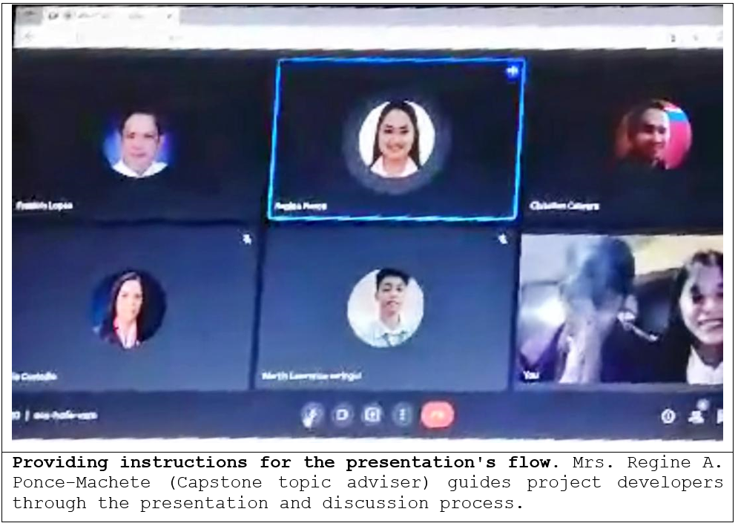

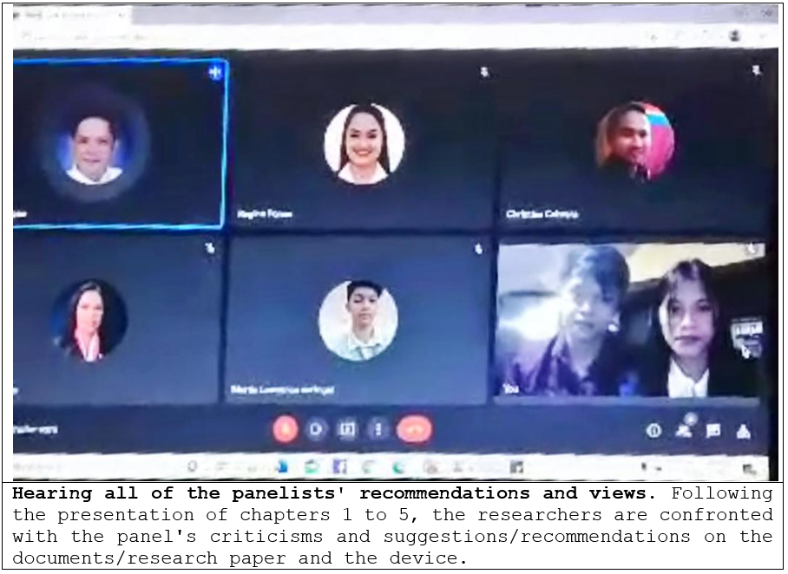

**APPENDIX L**

**Research/Capstone Project Waiver**

**RESEARCH/CAPSTONE PROJECT WAIVER**

We, **MARTIN LAWRENCE M. CARINGAL** and **CRISTAL JOY C. ALFEREZ**, of legal ages, the sole proponent of the Research/Capstone Project entitled “**ESEEDS: AN AUTOMATED AGRICULTURAL SEEDS VENDING MACHINE**”, hereby authorize our Adviser, Course Facilitator and the College of Computer Studies – Research Unit to submit our Research/Capstone Project for paper presentation, publication and funding.

Whereas, if the research project will be accepted in any form of publication or presentation, the proponents shall be assisted by their Adviser, Course Facilitator and/or CCS Research Unit Head. However, if the sole proponents unable to attend, the Adviser, Course Facilitator and/or CCS Research Unit Head may represent the group.

Whereas, the Adviser, Course Facilitator and/or CCS Research Unit Head may improve the content of the manuscript in accordance with the requirements set forth by the conference and forum organizers. If improvement had been made by the Adviser, Course Facilitator and/or CCS Research Unit Head, they will be a part of the research group as Co-Authors. The original proponents shall be notified and included as one of the proponents of the Research/Capstone Project.

Whereas, our actions and decisions will be beneficial/advantageous for all of us, to the College of Computer Studies and its respective programs.

### **MARTIN LAWRENCE M. CARINGAL CRISTAL JOY C. ALFEREZ**

Research Proponent Research Proponent

Date: Date: ___

### **APPENDIX M**

**Certificate Of Oral Research Presentation**

**APPENDIX N**

**ACM Format**

**ESEEDS: AN AUTOMATED AGRICULTURAL SEEDS VENDING MACHINE**

Martin Lawrence M. Caringal [1]  Cristal Joy C. Alferez [2]

Mindoro State University Mindoro State University

Masipit, Calapan City Masipit, Calapan City

Oriental Mindoro Oriental Mindoro

+639127476965 +639657346912

[rencecaringal@gmail.com](mailto:rencecaringal@gmail.com) [alferezcristaljoy@gmail.com](mailto:alferezcristaljoy@gmail.com)

# ABSTRACT

# This research paper developed an automated selling technology for various variety packs of east-west seeds products from within the store of La Luce Feeds Supply, with practical and useful features for the agricultural store, where it solves the problem of inconvenient direct interaction, where the store experiencing labor-intensive from many customers, managing sales and customer retention. The researchers used evolutionary prototyping model SDLC. System Development Life Cycle (SDLC) is a series of phases in the device developmental process.

# Its objectives are as follows: Develop an automated selling pack for a variety of east-west seeds; Integrate SMS to notify the administrator of remaining items and total sales; Incorporate SMS to allow the administrator to monitor and manage prices; Evaluate the developed project performance using ISO 25010; and implement the developed system.

# The device provides a proper feature of automated selling of variety pack of east-west seeds for the agricultural store, the device can generate text messages for timely notifications of remaining seeds of each container from the vending machine with the capacity load of 10 to 15 item each, at the same time it also sends text messages for the update of sales or as transaction records to the admin. It can also be changing its price of each container by the administrator, by using text messages specifically in sending code designated to change the prices in case that the price of the seeds needs to be updated. Environmental risk ready which the transaction is uninterruptible when power outage occurs unexpectedly. It can change coins if the customer has a remaining credit that already been inserted.

# The device's performance is assessed using ISO 25010, and data for the study is collected using a survey questionnaire. The device is user-friendly and exceedingly convenient as a result of the findings, needing little learning effort to operate. Customers, staff, the owner, IT experts, and others gave the overall performance a high evaluation (4.39 or "Effective") from a total of 50 respondents. The study satisfies the needs of the users, and all of the study's objectives were met.

# Keywords

# Automatic Vending Machine; Coin Dispense; Power Outage Free; Total Sales; Timely Notification

# INTRODUCTION

# The advancement of technology has had a significant impact on society. Life was difficult before modern technology, and daily activities took up much too much of our time. In modern culture, technology has become a particularly essential source of knowledge, and it has also opened up a number of new avenues for doing so. Access to education, medicine, industry, transportation, businesses and other services has been made easier thanks to contemporary technology. Our lives have substantially improved as a result of the convenience and efficiency afforded by technology.

# According to East-West Seed Company, in 1982, East-West Seed pioneered market-oriented plant breeding in Southeast Asia, with the goal of increasing smallholder farmers' income through high-quality vegetable seeds. Smallholder farmers were the primary customers at the time, and they remain so now.

# East-West Seeds has different types of seeds packaged each, which are sold in agricultural stores where the sale is usually traditional way or personal selling. Sometimes man power capabilities are lacking and something is needed that will boost sales or have more cost-effectiveness of selling seeds. The researchers came up with the idea of implementing technology to sell seeds to improve and ease the sale of seeds which is on what we called vending machines.

# The vending industry is rapidly growing. Vending machines can now be seen in malls and parks across the country. This new method of selling is already a big part of everyone's lives. This is why so many people fantasize of having a vending machine and profiting from such a convenient business.

# According to Solano, A., Duro, N., Dormido, R., & González, P. (2017), a vending machine is essentially a business that has been automated. Products are placed into a machine and are normally accessible for purchase 24 hours a day, seven days a week. Common types of vending machines are freshly sold or produced beverages, bottles; cans, snacks, and fresh food are frequent vending products. However, it appears like there is no limit to what can be sold nowadays. A vending machine's selection number or corresponding button corresponds to each item. Customers make their payment, choose the corresponding item number or button and then wait for their chosen product to be dispensed. Vending machines come in all shapes and sizes these days. Freshly brewed hot drinks, cold cans and nibbles, fresh filtered water, confectionery, fresh food, hot cuisine, and even non-edible objects are all examples. To entice customers, machines might mix eye-catching displays with exciting, new products, engaging films, and stereo sound. There are two types of vending machines: pay vend and free vend. Cashless payments are becoming increasingly prevalent in today's world. Customers can pay with a credit card, cash, or cell phone. Customers can choose the selection number or the relevant button after making payment and wait for their desired product to be dispensed.

# La Luce Feeds Supply is an agricultural store located in Barcenaga, Naujan Nautical Hwy. It was established in 1996 where they sell different agricultural supplies ranging but not limited to fertilizers, chemicals, seeds, animal feeds, supplements, and medicine. The owner of the store is Mrs. Maria Angeles C. Casubuan, the researcher's client for the project implementation. The Staff is currently employing traditional personal selling for all of its transactions where there are some issues that need to be resolved.

# According to La Luce Feeds supply store’s staff and the owner, reaching a limited number of customers, labor intensive, ineffective selling retention due to ranges or number of customers, unrestricted prices and fault distribution are some of the flaws that the store is experiencing right now.

# These problems were caused mainly by the manual selling operation within the store. This reason and problems led to the development of the ESEEDS: An Automated Agricultural Seeds Vending Machine.

# The project can help to maximize the store’s productivity, reduce delay and waiting time, cost- effectiveness, secure prices and its distribution to aid customers. Providing conveniences for agricultural customers and client’s agricultural store, with the help of technological implementation, which is the use of vending machine that allow customers to purchase the seeds they want to grow or plant, as well as features that allow customers to buy and pay without the need for assistance.

# REVIEW OF RELATED LITERATURE AND STUDIES

This chapter presents the review of related literature and studies of both foreign and local researches.

* 1. **Local Literature/System**

Existing vending machine use conventional control theory, which uses an absolute control value regardless of accuracy. This research done by Arifin [2017] suggested vending machine has the following advantages: transactions may be completed using short message service (SMS), all transactions can be watched online by the owner using Android, and the vending machine provides an early warning system (EWS) There is no need to establish a particular arrangement with the bank or telecommunication provider when the system fails, and it is also equipped with a battery backup when the electricity goes out. The Smart Vending Machine is made up of typical hardware components such an Arduino controller, a Wave com SMS Gateway module, servos, a power supply, a battery for backup power, a keypad and buttons for input, and an LCD 162 for display. From the several tests including normal transaction, online monitoring, and early warning system for electricity supply. The Smart Vending Machine was successful. And it has a big possibility of being mass produced.

The aim of the study of Velasco [2019] was to present a system that combines a conventional refrigerator, microcontrollers and a smart phone to create an inventory monitoring that can monitor the stocks inside the refrigerator wirelessly by accessing an Android application. The developed refrigerator uses a sensor network system that is installed in a respective compartment inside the refrigerator. Each sensor will transmit data to the microcontrollers, such as Arduino Yun and Arduino Uno, which are interconnected by the I2C communications. All data and images will be processed to provide the user an Internet of Things application through the cloud-based website Temboo. Temboo will have access to send data to the Dropbox. A smartphone is connected to the Dropbox where all the data and images are stored. The user can monitor the stocks or contents of the refrigerator wirelessly using an Android Application.

The major tasks of a modern vending corporation are revealed by Teji [2019] one of which is to provide as many payment methods as possible. Vending machines are commonly seen in large corporations, offices, organizations, and businesses. The aim of the vending company is to increase the speed of customer service. This paper describes its own development - a device for cashless payment. The device allows employees to pay for purchases using electronic passes. This solution allows vending companies not to worry about problems with cash (banknotes and coins), encashment and change, increasing the number of customers served per unit of time, what, in its turn, increases the income of the organization. And for the ultimate buyer, this method of payment saves time greatly. Vending machines are automated machines and devices designed to sell or buy products and pay for services.

# Foreign Literature/System

Existing SMS notification system is proven reliable for many, it helps to notify the user in real-time. This research done by Hassan [2020] GSM network coverage is widespread and mostly available in all parts of Malaysia; the notification system can use it. Users in the region, such as the village chief, the police station, and the nearby safety agencies, may receive notification messages. The Arduino UNO serves as the microcontroller of the device, performing tasks such as monitoring the height of the water, temperature, and humidity, and sending SMS through the GSM shield. An experiment was conducted using a small-scale prototype to simulate real flood conditions in order to validate the accuracy of the proposed system.

Monga and Singh [2021] nowadays, vending machines are well known among Japan, Malaysia and Singapore. The quantity of machines in these countries is on the top worldwide. This is due to the modern lifestyles which require fast food processing with high quality. This paper describes the designing of multi select machines using Finite State Machine Model with Auto-Billing Features. Finite State Machine (FSM) modelling is the most crucial part in developing the proposed model as this reduces the hardware.

John [2019] industrial vending machines (IVM) can help healthcare organizations address inventory management issues. Grounded in transaction cost economics and contingency theory, this research develops and empirically tests a model that highlights the critical role of information management in the link between buyer-supplier relationship quality and performance outcomes within the context of IVM implementation and use in the healthcare industry. Based on survey data from healthcare managers, results indicate that both information management and relationship quality are tied to a series of benefits in the context of collaborative buyer-supplier IVM agreements.

1. **METHODOLOGY**

This chapter presents the methods and procedures used to collect and analyze the data for the study of “ESEEDS: An Automated Agricultural Seeds Vending Machine” The data were evaluated and analyzed to provide an adequate result.

* 1. **Developmental Model**

The Evolutionary Prototyping model served as a guide for the researchers while they developed their project. Using this model helped them accomplish their objectives. The procedure will go on to the project's development once all requirements have been met and approved.

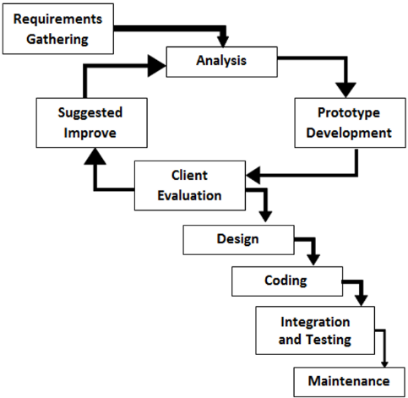

**Figure 1. Evolutionary Prototyping Model**

Figure 1 shows the Evolutionary Prototyping Model use in the study. As the device's system is studied, it is followed by the design and development of the machine, which is depicted in this diagram. This way the development of the device will be further improved.

* + 1. **Requirements Gathering**. The current situation was observed during this process in order to gather more information that would guide the development of this project. An interview was conducted, as well as the definition of requirements (user, content, and project requirements) and the development of a project plan. After the proposal has been approved, the analysis phase begins.
    2. **Analysis**. The previously developed devices were analyzed during this phase. During this stage, the flaws in the existing devices were discovered. The documented issues were examined in order to provide a general recommendation on how to solve such enhancements or replace the current study.
    3. **Prototype development.** During this phase, the researchers began working on a system that would allow personnel and clients to adapt to changing demands and requirements.
    4. **Client Evaluation.** At this point, the management team began to examine and evaluate the system for further areas of concern and improvement.
    5. **Suggested Improved.** The researchers began to modify and improve the system that the client had specified. The client reevaluated the system after the researchers assessed its progress to make sure it had improved.
    6. **Design**. During this phase, the researchers began to construct the system around the user’s requirements. When the system's requirements were determined, a preliminary or fast design was constructed.
    7. **Coding**. In this phase, the researchers began coding using Arduino IDE software that allowed the user to experience or envisage how the system works during this phase.
    8. **Integration and Testing.** At this phase, the researchers performed a series of tests to see if the system was functioning properly. The researchers demonstrated how it works to all respondents in order to guarantee that the user's needs were met and any flaws are remedied. Negative testing, unit testing, and acceptance testing were all used by the researchers.
    9. **Maintenance**. The system was deployed at this point, and the client assessed its performance. The client also checked to see if there were any issues so that the researchers could address them as soon as possible. The researchers tested the system twice a week to make sure it was working properly.
  1. **System Architecture**

# This section of the study displays the specific structures concerning the flow of system functions, and the completion of tasks in order for progress to be made

# 

# .

# Figure 2. System Architecture

# Figure 2 shows the system architecture method use in device development. The figure illustrates the architecture requirement and flow pattern for the device. The machine received an output if the customer inserted an amount or credit, after insertion of required credits, the customer purchased the desired item by pushing the designated button for its chosen item, on the other hand, immediately after the customer transaction, the machine processes and sends the SMS notification of remaining item and sales to the administrator to monitor and also configure the machine if changes of prices is needed. The SMS notification of GSM module helps the admin whether the machine is in need for the event of restocking. The SMS notification of total sales will also notify the admin after the purchased transaction is already made; the machine creates an SMS inventory of daily sales.

# Use Case Diagram

# This section depicts the graphical layout of how the first and secondary actors can interact with the project's function and scopes. It consists of the project's administrator, customer, and service provider. The project's mobile SMS interface will be accessible only to developers and staff.

# 

# Figure 3. Use Case Diagram of the Project

# The overall usage of the designed project is depicted in Figure 3. The staff is in charge in maintaining and managing the project functions as indicates above figure. While the customers take and the make purchased transaction from the machine. The service provider which is the smart telecom provides SMS service to the project’s SMS notification.

# RESULTS AND DISCUSSION

# In the implementation of this project, an evaluation was conducted to test the quality standard of the project using ISO 25010 criteria in terms of functional suitability, reliability, performance efficiency, usability, security, compatibility, maintainability and portability. This was evaluated by IT experts, owner, staff, customer and others of project.

# Table 1. Summary Results of the Evaluation

# 

# The results of the overall device evaluation by Customers, Staff, Owner, Others, and IT Expert are shown in Table 1 The project evaluation results, regarding the respondents' assessment of compliance with the ISO 25010 standards. It indicates that they rated the device as "Effective" with the obtained mean of each corresponding variable: functional suitability (M = 4.31), reliability (M = 4.17), performance efficiency (M = 4.6), usability (M = 4.52), security (M = 4.43), compatibility (M = 4.42), maintainability (M = 4.33), and portability (M = 4.34), with the overall mean of 4.39.

# CONCLUSION AND RECOMMENDATION

# The study's summary of findings, conclusions, and recommendations are presented in this chapter. This section comprises the researchers' observations and interpretations based on the survey results and data that was evaluated and analyzed.

# Conclusion

# During the development of the project, the researchers came to a number of conclusions and observations. The following are:

# The project provides an automated selling of seeds that aid an agricultural store, specifically the La Luce Feeds Supply.

# The project provides SMS inventory has been created throughout the implementation period of the vending machine by which the number of the remaining item and total sales received by the store staff.

# The researchers successfully integrated and developed a price change function, as a consequence of which the store staff managed the machine's pricing by sending specified SMS or code text messages utilized in updating prices.

# The proposed device satisfies the user's requirements in terms of functionality suitability, reliability, performance efficiency, usability, security, compatibility, maintainability, and portability, as indicated by the respondents’ good ratings. As the result of the study, the device verbal interpretation rated as "Effective", with an overall mean equal of 4.39.

# For clients who adopt the project, the project provides an implementation plan.

# REFERENCES

# [1] Arifin, S. M. S., Syai'in, M., Endrasmono, J., Sarena, S. T., Subiyanto, L., Setyoko, A. S., ... & Soeprijanto, A. (2017, July). Smart vending machine based on SMS gateway for general transactions. In 2017 15th International Conference on Quality in Research (QiR): International Symposium on Electrical and Computer Engineering (pp. 34-39). IEEE.

# [2] Asyhari, M. W., Sigit, R., & Sukaridhoto, S. (2019, September). Vending Machine Monitoring System Integrated with Webserver. In 2019 International Electronics Symposium (IES) (pp. 556-559). IEEE.

# [3] Babu, D. V., Subramanian, P., Karthikeyan, R., Akash, N., Phanindra, U., & Hemanth, G. (2020, December). RFID and GSM based Automatic Dispensing and Monitoring of Sanitary Napkin Vending Machine for Menstrual Hygiene among Women. In IOP Conference Series: Materials Science and Engineering (Vol. 993, No. 1, p. 012074). IOP Publishing.

# [4] Budiarto, R., Gunawan, N. K., & Nugroho, B. A. (2020, July). Smart Chicken Farming: Monitoring System for Temperature, Ammonia Levels, Feed in Chicken Farms. In IOP Conference Series: Materials Science and Engineering (Vol. 852, No. 1, p. 012175). IOP Publishing.

# [5] Baby, C. J., Singh, H., Srivastava, A., Dhawan, R., & Mahalakshmi, P. (2017, March). Smart bin: An intelligent waste alert and prediction system using machine learning approach. In 2017 International Conference on Wireless Communications, Signal Processing and Networking (WiSPNET) (pp. 771-774). IEEE.

# [6] Hassan, H., Mazlan, M. I. Q., Ibrahim, T. N. T., & Kambas, M. F. (2020, September). IOT System: Water Level Monitoring for Flood Management. In IOP Conference Series: Materials Science and Engineering (Vol. 917, No. 1, p. 012037). IOP Publishing.

# [7] Han-Markey, T. L., Wang, L., Schlotterbeck, S., Jackson, E. A., Gurm, R., Leidal, A., & Eagle, K. (2017). A public-school district's vending machine policy and changes over a 4-year period: Implementation of a national wellness policy. Public Health, 126(4), 335- 337.

# [8] Kohei Ushikubo (2018). Automatic vending machines that use only key cards to run. Sanden Holding Corp (USPTO). Publication of US4767917A.

# [9] Kanagasabapathi, V., Naveenraj, K., Neelavarnan, V., & Raj, S. N. (2019, March). Automatic chocolate vending machine. In the 2019 5th International Conference on Advanced Computing & Communication Systems (ICACCS) (pp. 584-587). IEEE.

# [10] Mulyani, S., & Hartono, R. (2019, November). Vending machines and influence on life in Indonesia. In IOP Conference Series: Materials Science and Engineering (Vol. 662, No. 5, p. 052001). IOP Publishing.

# [11] Matthews, M. A., & Horacek, T. M. (2017). Vending machine assessment methodology. A systematic review. Appetite, 90, 176-186.

**APPENDIX O**

**Curriculum Vitae**

**PERSONAL DATA**

**NAME :** Cristal Joy C. Alferez

**BIRTHDATE :** July 30, 1999

**BIRTHPLACE :** Malagasang II-A, Imus, Cavite

**AGE :** 22

**SEX :** Female

**CIVIL STATUS :** Single

**RELIGION :** Catholic

**NATIONALITY :** Filipino

**HEIGHT :** 5’1**”**

**FATHER :** Meriam C. Alferez

**MOTHER :** Alexander Z. Alferez

# EDUCATIONAL ATTAINMENT

**TERTIARY**

**Mindoro State University**

Masipit, Calapan City,

Oriental Mindoro

Bachelor of Science in Information Technology

2018 – 2022

# SECONDARY

**Oriental Mindoro National High school**

San Vicente East, Calapan City,

Oriental Mindoro

Senior High School

2016 – 2018

With Honors

# PRIMARY

**Bulusan Elementary School**

Bulusan, Calapan City,

Oriental Mindoro

Batch 2006 - 2012

# SKILLS

* Basic Computer Knowledge Literate

**Curriculum Vitae**

**PERSONAL DATA**

**NAME :** Martin Lawrence M.

Caringal

**BIRTHDATE :** July 02, 2000

**BIRTHPLACE :** Palhi Calapan City

**AGE :** 21

**SEX :** Male

**CIVIL STATUS :** Single

**RELIGION :** Catholic

**NATIONALITY :** Filipino

**HEIGHT :** 5’4**”**

**FATHER :** Faustino Jr. L. Caringal

**MOTHER :** Rosalie M. Caringal

# EDUCATIONAL ATTAINMENT

**TERTIARY**

**Mindoro State University**

Masipit, Calapan City,

Oriental Mindoro

Bachelor of Science in Information Technology

2018 – 2022

# SECONDARY

**Ama Computer Learning Center**

San Vicente East, Calapan City,

Oriental Mindoro

Senior High School

2016 – 2018

With Honors

# PRIMARY

**Parang Elementary School**

Parang, Calapan City,

Oriental Mindoro

Batch 2006 - 2012

# SKILLS

* + Computer System Servicing
  + Good Communication Skills